






Provide bell boy/porter services
D1.HFO.CL2.07
Trainer Guide

Provide bell boy/porter services

D1.HFO.CL2.07

Trainer Guide




Project Base
William Angliss Institute of TAFE
555 La Trobe Street
Melbourne 3000 Victoria
Telephone: | (03) 9606 2111
Facsimile: | (03) 9670 1330
Acknowledgements
Project Director: | Wayne Crosbie
Chief Writer: | Alan Hickman
Subject Writer: | Evelyn Collins and Linda Wilson
Project Manager/Editor: | Alan Maguire
Editor: | Jim Irwin
DTP/Production: | Daniel Chee, Mai Vu, Jirayu Thangcharoensamut, Kaly Quach

The Association of Southeast Asian Nations (ASEAN) was established on 8 August 1967. The Member States of the Association are Brunei Darussalam, Cambodia, Indonesia, Lao PDR, Malaysia, Myanmar, Philippines, Singapore, Thailand and Viet Nam.
The ASEAN Secretariat is based in Jakarta, Indonesia.
General Information on ASEAN appears online at the ASEAN Website: www.asean.org.
All text is produced by William Angliss Institute of TAFE for the ASEAN Project on “Toolbox Development for Front Office, Food and Beverage Services and Food Production Divisions”.
This publication is supported by the Australian Government’s aid program through the ASEAN-Australia Development Cooperation Program Phase II (AADCP II).
Copyright: Association of Southeast Asian Nations (ASEAN) 2013.
All rights reserved.
Disclaimer
Every effort has been made to ensure that this publication is free from errors or omissions. However, you should conduct your own enquiries and seek professional advice before relying on any fact, statement or matter contained in this book. The ASEAN Secretariat and William Angliss Institute of TAFE are not responsible for any injury, loss or damage as a result of material included or omitted from this course. Information in this module is current at the time of publication. Time of publication is indicated in the date stamp at the bottom of each page.
Some images appearing in this resource have been purchased from stock photography suppliers Shutterstock and iStockphoto and other third party copyright owners and as such are non-transferable and non-exclusive. Clip arts, font images and illustrations used are from the Microsoft Office Clip Art and Media Library. Some images have been provided by and are the property of William Angliss Institute.
Additional images have been sourced from Flickr and SXC and are used under Creative Commons licence: http://creativecommons.org/licenses/by/2.0/deed.en
File name: TG_Provide_bell_boy-porter_services_refined.docx





Table of contents
Competency Based Training (CBT) and assessment - An introduction for trainers 1
Competency standard 11
Notes and PowerPoint slides 21
Recommended training equipment 69
Instructions for Trainers for using PowerPoint – Presenter View 71
Appendix – ASEAN acronyms 73

Competency Based Training (CBT) and assessment - An introduction for trainers

Competency
Competency refers to the ability to perform particular tasks and duties to the standard of performance expected in the workplace.
Competency requires the application of specified knowledge, skills and attitudes relevant to effective participation, consistently over time and in the workplace environment.
The essential skills and knowledge are either identified separately or combined.
Knowledge identifies what a person needs to know to perform the work in an informed and effective manner.
Skills describe the application of knowledge to situations where understanding is converted into a workplace outcome.
Attitude describes the founding reasons behind the need for certain knowledge or why skills are performed in a specified manner.
Competency covers all aspects of workplace performance and involves:
- Performing individual tasks
- Managing a range of different tasks
- Responding to contingencies or breakdowns
- Dealing with the responsibilities of the workplace
- Working with others.

Unit of Competency
Like with any training qualification or program, a range of subject topics are identified that focus on the ability in a certain work area, responsibility or function.
Each manual focuses on a specific unit of competency that applies in the hospitality workplace.
In this manual a unit of competency is identified as a ‘unit’.
Each unit of competency identifies a discrete workplace requirement and includes:
- Knowledge and skills that underpin competency
- Language, literacy and numeracy
- Occupational safety and health requirements.
Each unit of competency must be adhered to in training and assessment to ensure consistency of outcomes.

Element of Competency
An element of competency describes the essential outcomes within a unit of competency.
The elements of competency are the basic building blocks of the unit of competency. They describe in terms of outcomes the significant functions and tasks that make up the competency.
In this manual elements of competency are identified as an ‘element’.

Performance criteria
Performance criteria indicate the standard of performance that is required to demonstrate achievement within an element of competency. The standards reflect identified industry skill needs.
Performance criteria will be made up of certain specified skills, knowledge and attitudes.

Learning
For the purpose of this manual learning incorporates two key activities:
- Training
- Assessment.
Both of these activities will be discussed in detail in this introduction.
Today training and assessment can be delivered in a variety of ways. It may be provided to participants:
- On-the-job – in the workplace
- Off-the-job – at an educational institution or dedicated training environment
- As a combination of these two options.
No longer is it necessary for learners to be absent from the workplace for long periods of time in order to obtain recognised and accredited qualifications.

Learning Approaches
This manual will identify two avenues to facilitate learning:
Competency Based Training (CBT)
This is the strategy of developing a participant’s competency.
Educational institutions utilise a range of training strategies to ensure that participants are able to gain the knowledge and skills required for successful:
- Completion of the training program or qualification
- Implementation in the workplace.
The strategies selected should be chosen based on suitability and the learning styles of participants.

Competency Based Assessment (CBA)
This is the strategy of assessing competency of a participant.
Educational institutions utilise a range of assessment strategies to ensure that participants are assessed in a manner that demonstrates validity, fairness, reliability, flexibility and fairness of assessment processes.

Flexibility in Learning
It is important to note that flexibility in training and assessment strategies is required to meet the needs of participants who may have learning difficulties. The strategies used will vary, taking into account the needs of individual participants with learning difficulties. However they will be applied in a manner which does not discriminate against the participant or the participant body as a whole.
Catering for Participant Diversity
Participants have diverse backgrounds, needs and interests. When planning training and assessment activities to cater for individual differences, trainers and assessors should:
- Consider individuals’ experiences, learning styles and interests
- Develop questions and activities that are aimed at different levels of ability
- Modify the expectations for some participants
- Provide opportunities for a variety of forms of participation, such as individual, pair and small group activities
- Assess participants based on individual progress and outcomes.
The diversity among participants also provides a good reason for building up a learning community in which participants support each other’s learning.
Participant Centred Learning
This involves taking into account structuring training and assessment that:
- Builds on strengths – Training environments need to demonstrate the many positive features of local participants (such as the attribution of academic success to effort, and the social nature of achievement motivation) and of their trainers (such as a strong emphasis on subject disciplines and moral responsibility). These strengths and uniqueness of local participants and trainers should be acknowledged and treasured
- Acknowledges prior knowledge and experience – The learning activities should be planned with participants’ prior knowledge and experience in mind
- Understands learning objectives – Each learning activity should have clear learning objectives and participants should be informed of them at the outset. Trainers should also be clear about the purpose of assignments and explain their significance to participants
- Teaches for understanding – The pedagogies chosen should aim at enabling participants to act and think flexibly with what they know
- Teaches for independent learning – Generic skills and reflection should be nurtured through learning activities in appropriate contexts of the curriculum. Participants should be encouraged to take responsibility for their own learning
- Enhances motivation – Learning is most effective when participants are motivated. Various strategies should be used to arouse the interest of participants
- Makes effective use of resources – A variety of teaching resources can be employed as tools for learning
- Maximises engagement – In conducting learning activities, it is important for the minds of participants to be actively engaged
- Aligns assessment with learning and teaching – Feedback and assessment should be an integral part of learning and teaching
- Caters for learner diversity – Trainers should be aware that participants have different characteristics and strengths and try to nurture these rather than impose a standard set of expectations.
Active Learning
The goal of nurturing independent learning in participants does not imply that they always have to work in isolation or solely in a classroom. On the contrary, the construction of knowledge in tourism and hospitality studies can often best be carried out in collaboration with others in the field. Sharing experiences, insights and views on issues of common concern, and working together to collect information through conducting investigative studies in the field (active learning) can contribute a lot to their eventual success.
Active learning has an important part to play in fostering a sense of community in the class. First, to operate successfully, a learning community requires an ethos of acceptance and a sense of trust among participants, and between them and their trainers. Trainers can help to foster acceptance and trust through encouragement and personal example, and by allowing participants to take risks as they explore and articulate their views, however immature these may appear to be. Participants also come to realise that their classmates (and their trainers) are partners in learning and solving.
Trainers can also encourage cooperative learning by designing appropriate group learning tasks, which include, for example, collecting background information, conducting small-scale surveys, or producing media presentations on certain issues and themes. Participants need to be reminded that, while they should work towards successful completion of the field tasks, developing positive peer relationships in the process is an important objective of all group work.

Competency Based Training (CBT)
Principle of Competency Based Training
Competency based training is aimed at developing the knowledge, skills and attitudes of participants, through a variety of training tools.
Training Strategies
The aims of this curriculum are to enable participants to:
- Undertake a variety of subject courses that are relevant to industry in the current environment
- Learn current industry skills, information and trends relevant to industry
- Learn through a range of practical and theoretical approaches
- Be able to identify, explore and solve issues in a productive manner
- Be able to become confident, equipped and flexible managers of the future
- Be ‘job ready’ and a valuable employee in the industry upon graduation of any qualification level.
To ensure participants are able to gain the knowledge and skills required to meet competency in each unit of competency in the qualification, a range of training delivery modes are used.
Types of Training
In choosing learning and teaching strategies, trainers should take into account the practical, complex and multi-disciplinary nature of the subject area, as well as their participant’s prior knowledge, learning styles and abilities.
Training outcomes can be attained by utilising one or more delivery methods:
Lecture/Tutorial
This is a common method of training involving transfer of information from the trainer to the participants. It is an effective approach to introduce new concepts or information to the learners and also to build upon the existing knowledge. The listener is expected to reflect on the subject and seek clarifications on the doubts.
Demonstration
Demonstration is a very effective training method that involves a trainer showing a participant how to perform a task or activity. Through a visual demonstration, trainers may also explain reasoning behind certain actions or provide supplementary information to help facilitate understanding.
Group Discussions
Brainstorming in which all the members in a group express their ideas, views and opinions on a given topic, is a free flow and exchange of knowledge among the participants and the trainer. The discussion is carried out by the group on the basis of their own experience, perceptions and values. This will facilitate acquiring new knowledge. When everybody is expected to participate in the group discussion, even the introverted persons will also get stimulated and try to articulate their feelings.
The ideas that emerge in the discussions should be noted down and presentations are to be made by the groups. Sometimes consensus needs to be arrived at on a given topic. Group discussions are to be held under the moderation of a leader guided by the trainer. Group discussion technique triggers thinking process, encourages interactions and enhances communication skills.
Role Play
This is a common and very effective method of bringing into the classroom real life situations, which may not otherwise be possible. Participants are made to enact a particular role so as to give a real feel of the roles they may be called upon to play. This enables participants to understand the behaviour of others as well as their own emotions and feelings. The instructor must brief the role players on what is expected of them. The role player may either be given a ready-made script, which they can memorize and enact, or they may be required to develop their own scripts around a given situation. This technique is extremely useful in understanding creative selling techniques and human relations. It can be entertaining and energizing and it helps the reserved and less literate to express their feelings.

Simulation Games
When trainees need to become aware of something that they have not been conscious of, simulations can be a useful mechanism. Simulation games are a method based on "here and now" experience shared by all the participants. The games focus on the participation of the trainees and their willingness to share their ideas with others. A "near real life" situation is created providing an opportunity to which they apply themselves by adopting certain behaviour. They then experience the impact of their behaviour on the situation. It is carried out to generate responses and reactions based on the real feelings of the participants, which are subsequently analysed by the trainer.
While use of simulation games can result in very effective learning, it needs considerable trainer competence to analyse the situations.
Individual /Group Exercises
Exercises are often introduced to find out how much the participant has assimilated. This method involves imparting instructions to participants on a particular subject through use of written exercises. In the group exercises, the entire class is divided into small groups, and members are asked to collaborate to arrive at a consensus or solution to a problem.
Case Study
This is a training method that enables the trainer and the participant to experience a real life situation. It may be on account of events in the past or situations in the present, in which there may be one or more problems to be solved and decisions to be taken. The basic objective of a case study is to help participants diagnose, analyse and/or solve a particular problem and to make them internalize the critical inputs delivered in the training. Questions are generally given at the end of the case study to direct the participants and to stimulate their thinking towards possible solutions. Studies may be presented in written or verbal form.
Field Visit
This involves a carefully planned visit or tour to a place of learning or interest. The idea is to give first-hand knowledge by personal observation of field situations, and to relate theory with practice. The emphasis is on observing, exploring, asking questions and understanding. The trainer should remember to brief the participants about what they should observe and about the customs and norms that need to be respected.
Group Presentation
The participants are asked to work in groups and produce the results and findings of their group work to the members of another sub-group. By this method participants get a good picture of each other's views and perceptions on the topic and they are able to compare them with their own point of view. The pooling and sharing of findings enriches the discussion and learning process.
Practice Sessions
This method is of paramount importance for skills training. Participants are provided with an opportunity to practice in a controlled situation what they have learnt. It could be real life or through a make-believe situation.

Games
This is a group process and includes those methods that involve usually fun-based activity, aimed at conveying feelings and experiences, which are everyday in nature, and applying them within the game being played. A game has set rules and regulations, and may or may not include a competitive element. After the game is played, it is essential that the participants be debriefed and their lessons and experiences consolidated by the trainer.
Research
Trainers may require learners to undertake research activities, including online research, to gather information or further understanding about a specific subject area.

Competency Based Assessment (CBA)
Principle of Competency Based Assessment
Competency based assessment is aimed at compiling a list of evidence that shows that a person is competent in a particular unit of competency.
Competencies are gained through a multitude of ways including:
- Training and development programs
- Formal education
- Life experience
- Apprenticeships
- On-the-job experience
- Self-help programs.
All of these together contribute to job competence in a person. Ultimately, assessors and participants work together, through the ‘collection of evidence’ in determining overall competence.
This evidence can be collected:
- Using different formats
- Using different people
- Collected over a period of time.
The assessor, who is ideally someone with considerable experience in the area being assessed, reviews the evidence and verifies the person as being competent or not.
Flexibility in Assessment
Whilst allocated assessment tools have been identified for this subject, all attempts are made to determine competency and suitable alternate assessment tools may be used, according to the requirements of the participant.
The assessment needs to be equitable for all participants, taking into account their cultural and linguistic needs.
Competency must be proven regardless of:
- Language
- Delivery Method
- Assessment Method.
Assessment Objectives
The assessment tools used for subjects are designed to determine competency against the ‘elements of competency’ and their associated ‘performance criteria’.
The assessment tools are used to identify sufficient:
- Knowledge, including underpinning knowledge
- Skills
- Attitudes
Assessment tools are activities that trainees are required to undertake to prove participant competency in this subject.
All assessments must be completed satisfactorily for participants to obtain competence in this subject. There are no exceptions to this requirement, however, it is possible that in some cases several assessment items may be combined and assessed together.
Types of Assessment
Allocated Assessment Tools
There are a number of assessment tools that are used to determine competency in this subject:
- Work projects
- Written questions
- Oral questions
- Third Party Report
- Observation Checklist.
Instructions on how assessors should conduct these assessment methods are explained in the Assessment Manuals.
Alternative Assessment Tools
Whilst this subject has identified assessment tools, as indicated above, this does not restrict the assessor from using different assessment methods to measure the competency of a participant.
Evidence is simply proof that the assessor gathers to show participants can actually do what they are required to do.
Whilst there is a distinct requirement for participants to demonstrate competency, there are many and diverse sources of evidence available to the assessor.
Ongoing performance at work, as verified by a supervisor or physical evidence, can count towards assessment. Additionally, the assessor can talk to customers or work colleagues to gather evidence about performance.
A range of assessment methods to assess competency include:
- Practical demonstrations
- Practical demonstrations in simulated work conditions
- Problem solving
- Portfolios of evidence
- Critical incident reports
- Journals
- Oral presentations
- Interviews
- Videos
- Visuals: slides, audio tapes
- Case studies
- Log books
- Projects
- Role plays
- Group projects
- Group discussions
- Examinations.
Recognition of Prior Learning
Recognition of Prior Learning is the process that gives current industry professionals who do not have a formal qualification, the opportunity to benchmark their extensive skills and experience against the standards set out in each unit of competency/subject.
Also known as a Skills Recognition Audit (SRA), this process is a learning and assessment pathway which encompasses:
- Recognition of Current Competencies (RCC)
- Skills auditing
- Gap analysis and training
- Credit transfer.
Assessing competency
As mentioned, assessment is the process of identifying a participant’s current knowledge, skills and attitudes sets against all elements of competency within a unit of competency. Traditionally in education, grades or marks were given to participants, dependent on how many questions the participant successfully answered in an assessment tool.
Competency based assessment does not award grades, but simply identifies if the participant has the knowledge, skills and attitudes to undertake the required task to the specified standard.
Therefore, when assessing competency, an assessor has two possible results that can be awarded:
- Pass Competent (PC)
- Not Yet Competent (NYC)
- Pass Competent (PC).
If the participant is able to successfully answer or demonstrate what is required, to the expected standards of the performance criteria, they will be deemed as ‘Pass Competent’ (PC).
The assessor will award a ‘Pass Competent’ (PC) if they feel the participant has the necessary knowledge, skills and attitudes in all assessment tasks for a unit.
Not Yet Competent’ (NYC)
If the participant is unable to answer or demonstrate competency to the desired standard, they will be deemed to be ‘Not Yet Competent’ (NYC).
This does not mean the participant will need to complete all the assessment tasks again. The focus will be on the specific assessment tasks that were not performed to the expected standards.
The participant may be required to:
a) Undertake further training or instruction
b) Undertake the assessment task again until they are deemed to be ‘Pass Competent’.

Competency standard
UNIT TITLE: PROVIDE BELL BOY/PORTER SERVICES |  |  |  | NOMINAL HOURS: 15
UNIT NUMBER: D1.HFO.CL2.07
UNIT DESCRIPTOR: This unit deals with skills and knowledge required to provide bell boy/porter services within an accommodation property
ELEMENTS AND PERFORMANCE CRITERIA | UNIT VARIABLE AND ASSESSMENT GUIDE
Element 1: Identify the role of a bell boy/porter  - Describe the services delivered by a bell boy/porter  - Locate the position of bell boy/porter within the enterprise  - Identify the personal characteristics required of a bell boy/porter  - Describe grooming and personal presentation standards for a bell boy/porter  - Interpret enterprise policies and procedures for the provision of bell boy/porter services  - Identify and explain the role of communication in bell boy/porter service provision  Element 2: Assist with guest arrivals  - Prepare for expected guest arrivals  - Comply with special requests  - Assist guests on arrival as required | Unit Variables  The Unit Variables provide advice to interpret the scope and context of this unit of competence, allowing for differences between enterprises and workplaces. It relates to the unit as a whole and facilitates holistic assessment  This unit applies to the accommodation sector of the hospitality industry and has a close working and support relationship with the front office department and to a lesser extent, housekeeping, within the labour divisions of the hotel and travel industries and may include:  - Front Office  Services delivered by a bell boy/porter may include:  Greeting guests  Opening doors  Moving guest luggage  Complying with guest requests  Liaising and supporting front office dealings with guests  Supporting service delivery to guests from other departments as required  Providing general support services for the enterprise.
- Escort guests to rooms  - Adhere to enterprise policies and procedures for luggage handling  Element 3: Assist with guest departures  - Respond to guest requests for help when departing  - Transport luggage for departing guests  - Operate in-house guest luggage storage facilities  Element 4: Assist other departments  - Support room service requests for assistance  - Provide general fetching and carrying duties for departments as appropriate  - Assist in emergency cleaning requirements  - Assist in emergency situations and procedures, as required  - Back-fill in departments and service areas where required  - Manage difficult patrons  Element 5: Provide concierge services  - Distribute mail and messages to guests  - Arrange wake-up calls for guests  - Organise transport for guests during their stay  - Arrange transfers for departing guests | Personal characteristics will include:  Tact, diplomacy and discretion  Etiquette and good manners  Politeness and civility  Honesty and dedication  Willingness to be of genuine service  An unbiased and prejudice-free disposition.  Grooming and personal presentation standards may be related to:  Wearing of uniform  Personal hygiene  Personal appearance.  Enterprise policies and procedures may relate to:  Service standards and protocols  Honesty  Treatment of VIPs  Use of enterprise equipment and facilities  Complimentary goods and services  Discretionary authority to act on behalf of the organisation.  The role of communication must include:  Use of appropriate verbal and non-verbal communication techniques  Building rapport and goodwill  Building trust and confidence with the guest  Honesty
- Organise luggage pick-up from rooms and destinations  - Page guests as required  - Prepare in-house guest information/directories  - Respond to guest requests for advice and local knowledge | Tact, diplomacy and discretion  Privacy and confidentiality issues  Promotional and selling skills  Recommending and advising guests  Taking guest reservations for internal house services and facilities.  Expected guest arrivals may be identified from:  Discussions with front office staff  Reviewing guest arrivals lists provided by reception.
Special requests may include:
Assisting housekeeping in readying rooms
Assisting housekeeping by preparing and locating designated items into rooms
Placing designated items (such as food and beverages) into rooms
Liaising with room service to assist in provision of nominated room service
Complying with in-house protocols for welcoming VIPs.
Assist guests on arrival may include:
Greeting and welcoming guests
Assisting with luggage, including removing luggage from cars, coaches, taxis and placing onto porter trolleys
Escorting or directing guests to reception for check-in
Providing valet parking services.
Escort guests should include:
Moving guest luggage
Explaining establishment facilities, services and products
Promoting designated aspects of the prospects, such as dining, bars, sports facilities, entertainment, house facilities (laundry, cleaning, repairs, secretarial, child minding, translator, room service), in room facilities (mini bar, movies, internet, safe deposits)
Offering to reserve table at in-house dining facilities
Opening guest room
Carrying luggage into room and placing same in accordance with guest wishes
Checking operational readiness of all in room equipment, items and facilities
Explaining in room facilities and demonstrating in room features to guests, such as lights, television, telephone, air conditioning, curtains, message systems
Wishing guests a pleasant stay.
Enterprise policies and procedures for luggage handling should relate to:
Luggage marking and tagging systems
Carrying capacities for luggage trolleys
Specified routes to be taken when moving luggage through public areas
Observing enterprise limitations and restrictions regarding areas into which guest luggage may not be taken
Safe manual handling procedures for handling luggage, including designated requirements for bending, carrying, lifting, loading and unloading trolleys, loading and unloading luggage from vehicles, specific procedures for dealing with ‘heavy’, ‘very heavy’ and ‘fragile’ items
Placement of luggage within guest rooms
Handling protocols for dealing with group arrivals and departures.
Guest requests for help when departing may include:
Folding clothes and packing luggage
Obtaining special requests to assist guests with packing, such as cardboard, foam, paper, extra bags.
Transport luggage for departing guests may include:
Moving luggage to reception
Placing luggage into storage
Loading luggage into/onto vehicles for departure and transfers
Weighing guest luggage
Assisting guests to mail/send extra luggage and items home.
In-house guest luggage storage facilities may include:
Tagging guest luggage and giving guest their claim tag
Physically placing items into luggage storage areas
Providing for the security of stored luggage
Overseeing luggage claims by guests
Ensuring guest luggage and luggage contents are not damaged in storage.
Room service requests may relate to:
Assisting in the movement of room service trolleys to guest room
Assisting in room service set up and presentation
Assisting in room service clearing.
General fetching and carrying duties may include:
Carrying supplies and stock from stores to departments
Responding to in room guest requests for extra or special items
Carrying change to bars and other cash points.
Emergency cleaning requirements may relate to:
Spot cleaning
Cleaning up spills and public area accidents, mess and damage.
Back-fill in departments and service areas may relate to:
Providing short-term relief for operational staff who have been temporarily allocated to other duties
Assisting in times of high demand
Filling in for staff who have been injured or had to leave work due to illness or other pressing reasons.
Manage difficult patrons may include:
Using progressive intervention steps
Involving other staff to assist
Using physical control tactics.
Mail and messages may include:
Physical delivery of messages and mail to rooms
Placing mail and messages into guest pigeon holes
Following up mail and messages to ensure guest received them
Posting items on behalf of guest
Processing charges for mail to guest account.
Transport for guests during their stay may include:
Advising on public transport options
Arranging a hire car
Arranging limousine service
Providing local maps and information on transport options
Booking local tours and trips.
In-house guest information/directories may relate to:
Obtaining general tourist information and making it readily available
Preparing specialised half-day and one-day trips for guests with special and general interests
Updating contents of directories to keep them current and relevant to guest profiles.
Guest requests for advice may include providing advice, information and recommendations on a variety of topics such as:
Tourist attractions
Dining options
Transport
Local culture
Religious and historic points of interests
Gardens and parks
Medical and emergency contacts
Churches and religious services
Nightlife
Personal services
Making phone calls and enquiries on behalf of guests
Maintaining guest privacy and confidentiality.
Assessment Guide
The following skills and knowledge must be assessed as part of this unit:
The enterprise’s policies and procedures in regard to guest service delivery
Appropriate written, verbal and non-verbal communication, interpersonal guest service and rapport building skills
Negotiation and problem solving skills
Liaison skills with internal and external providers
Research and acquisition skills to source items requested by guests
Problem solving abilities to resolve guest issues
Ability to act as agent for the guest.
Linkages To Other Units
Develop and update local knowledge
Maintain hospitality industry knowledge
Manage and resolve conflict situations
Promote hospitality products and services
Promote products and services to customers
Receive and resolve customer complaints
Provide advice to patrons on food and beverage services
Manage intoxicated persons
Provide information about in-house services
Provide for the safety of VIPs
Communicate on the telephone.
Critical Aspects of Assessment
Evidence of the following is essential:
Demonstrated ability to provide a nominated range of support services to designated departments within the host enterprise
Demonstrated ability to assist individual guests on arrival which must include assistance with luggage, escorting to rooms and presentation and explanation of in room facilities and features
Demonstrated ability to assist groups of guests on arrival which must include assistance with luggage, escorting to rooms and presentation and explanation of in room facilities and features
Demonstrated ability to assist individual guests on departures which must include assistance with luggage and on departure needs as required
Demonstrated ability to assist groups of guests on departures which must include assistance with luggage and on departure needs as required.
Context of Assessment
Assessment must ensure:
Actual or simulated workplace delivery of a nominated range of bell boy/porter services and support activities.
Resource Implications
Training and assessment must include the use of real or simulated establishment facilities, procedures, documentation and guests.
Assessment Methods
The following methods may be used to assess competency for this unit:
Observation of practical candidate performance
Role plays
Oral and written questions
Third party reports completed by a supervisor
Project and assignment work.
Key Competencies in this Unit
Level 1 = competence to undertake tasks effectively
Level 2 = competence to manage tasks
Level 3 = competence to use concepts for evaluating
 | Key Competencies | Level | Examples
 | Collecting, organising and analysing information | 2 | Research in-house and local information; prepare in-house service directories
 | Communicating ideas and information | 2 | Speak with guests; explain in room features and facilities; provide concierge advice and information
 | Planning and organising activities | 1 | Respond to guest requests for assistance
 | Working with others and in teams | 2 | Assist co-workers in the delivery of guest and customer services
 | Using mathematical ideas and techniques | 1 | Count and weigh guest luggage
 | Solving problems | 1 | Deal with guest complaints; resolve lost luggage issues; meet guest requests
 | Using technology | 1 | Use electronic key systems; use computerised reservation systems

Notes and PowerPoint slides
Slide
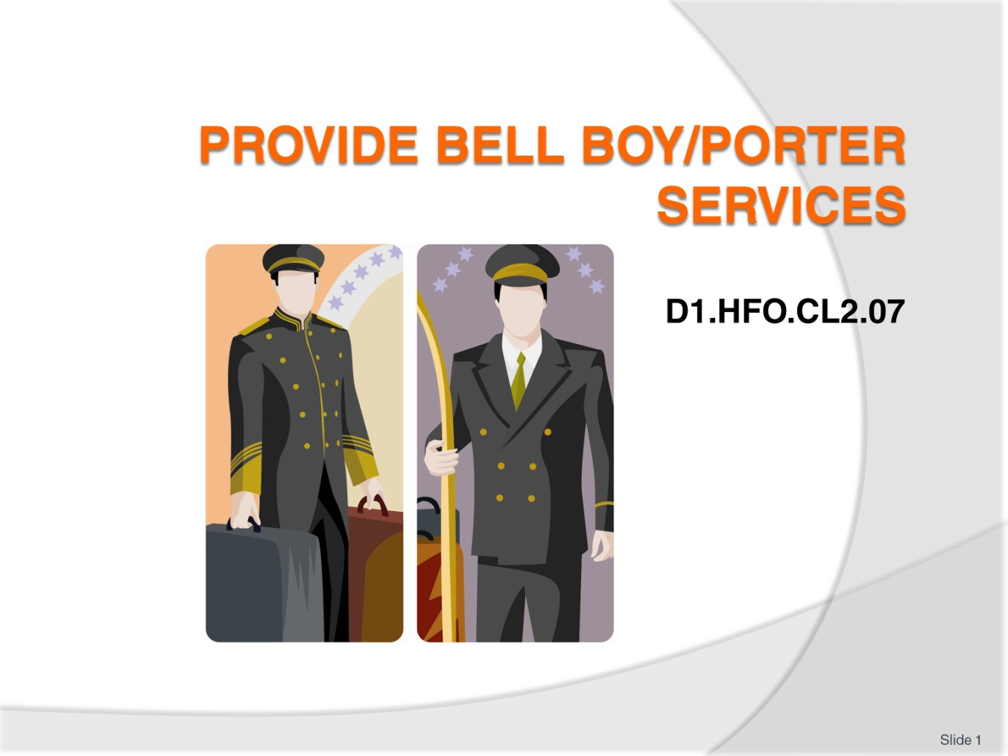
Slide No | Trainer Notes
 | Trainer welcomes trainees to class and informs them the unit titled “Provide Bell Boy/Porter Services”.

Slide
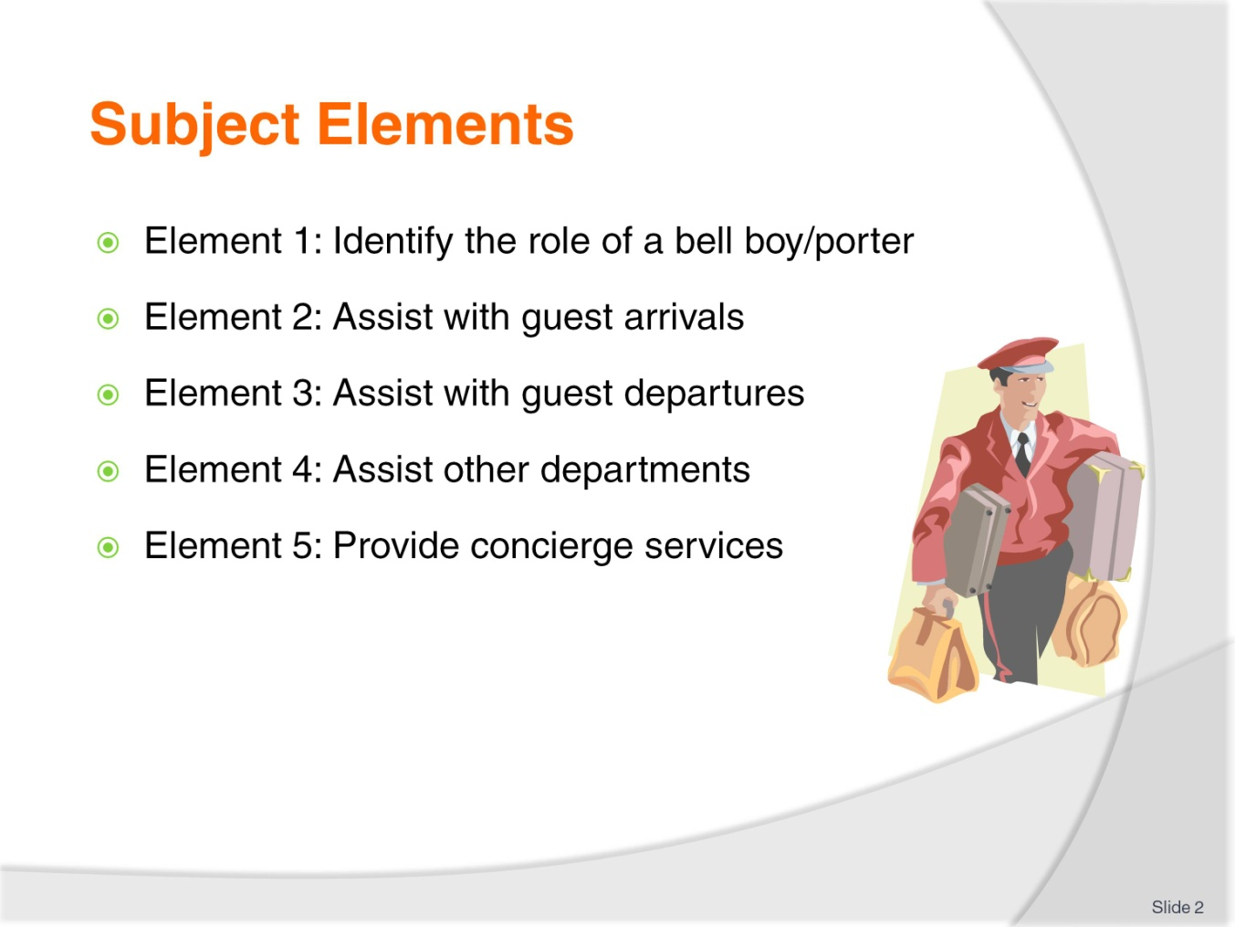
Slide No | Trainer Notes
 | Trainer briefs trainees the five subject elements.

Slide
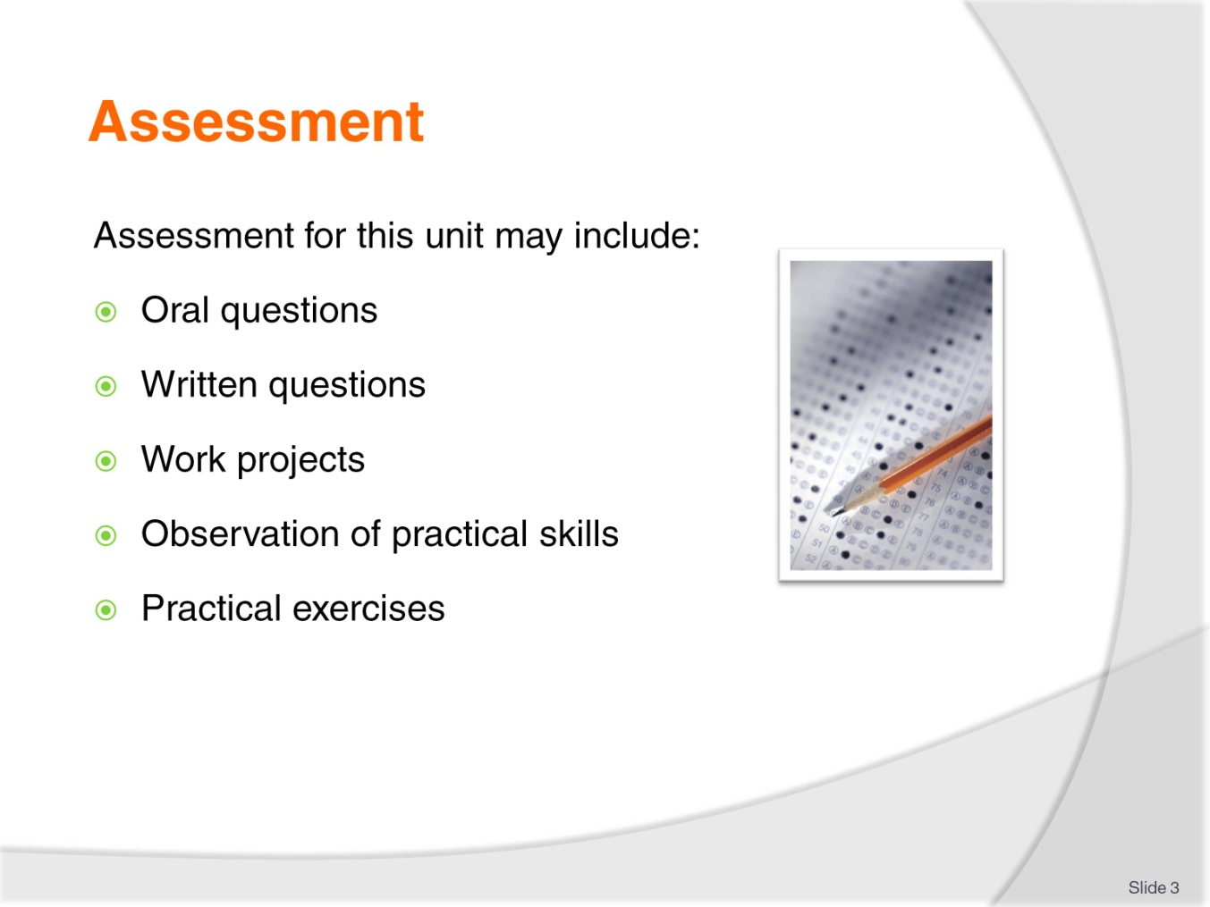
Slide No | Trainer Notes
Trainer advises that assessment for this Unit may take several forms all of which are aimed at verifying they have achieved competency for the Unit as required.
Trainer indicates the methods of assessment that will be applied to them for this Unit.

Slide
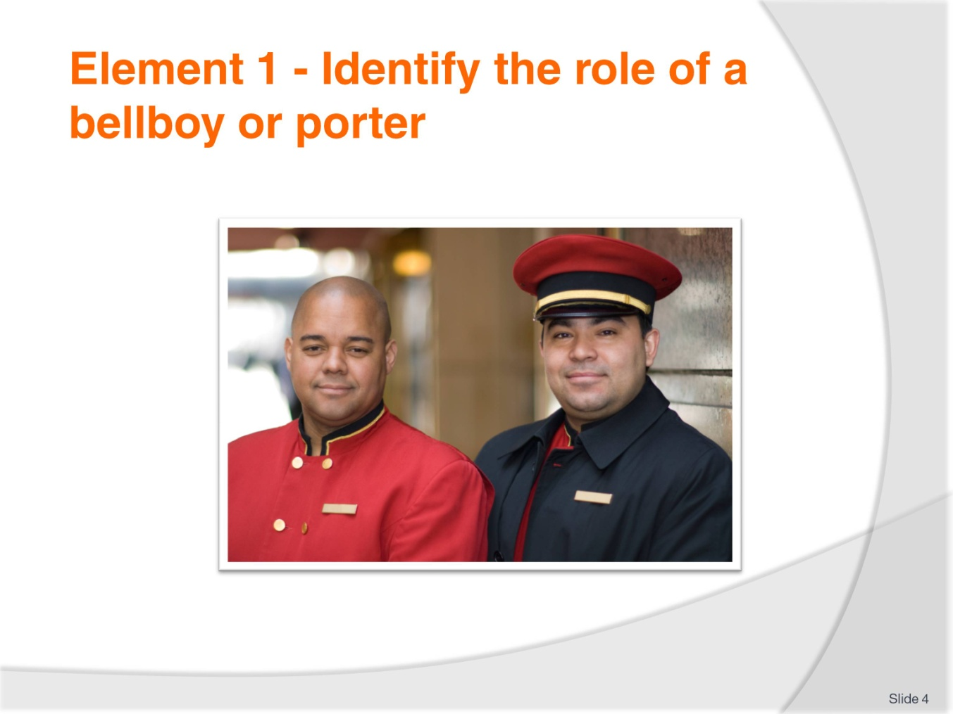
Slide No | Trainer Notes
 | Trainer introduces Element 1 - Identify the role of a bellboy or porter.

Slide
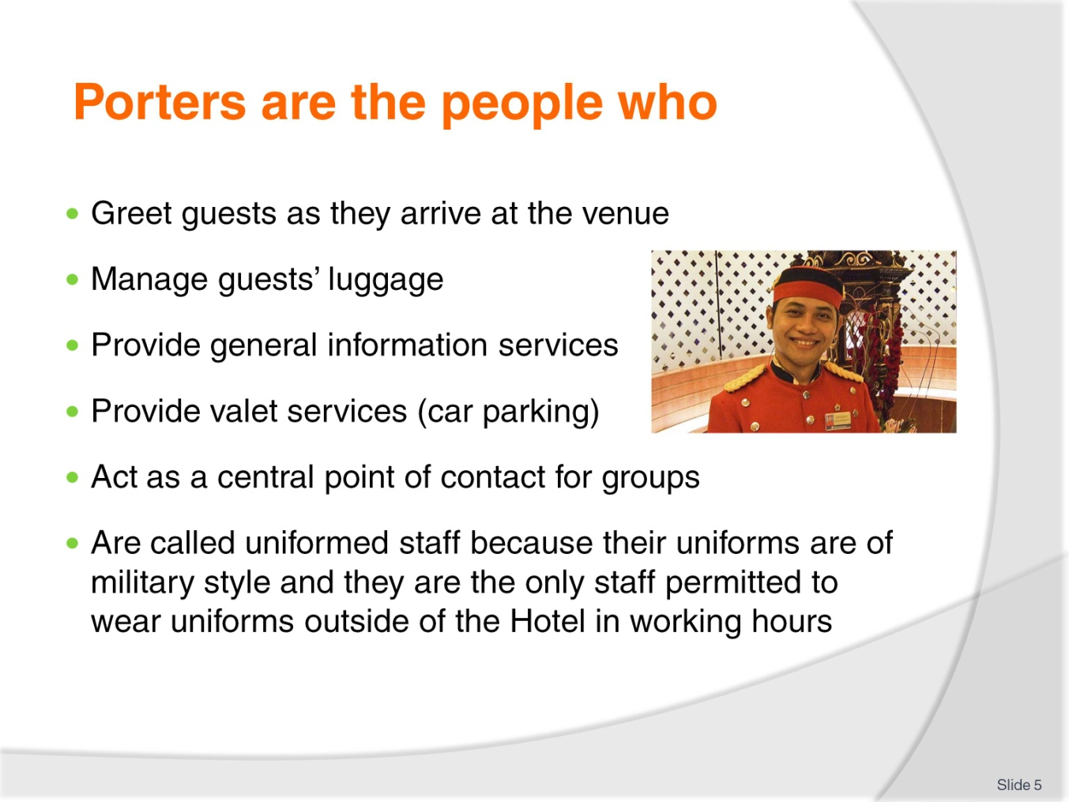
Slide No | Trainer Notes
Porters’ duties include:
Meeting and Greeting the guest, and assisting with luggage
Rooming the Guest; showing them how their room operates, location of light switches, environmental controls
Luggage management
Marketing the areas of the Hotel or resort including in house businesses and services
Taking messages or mail for in house guests.
Solving guest’s problems and queries about local and recreational facilities.
In some venues staff are multi-skilled and cross-trained, meaning that several different jobs will be performed by the same person.
For example:
The concierge and the porter can be the same person
Doorperson duties may be shared by the porters or concierge person
Sometimes porters share front desk duties and staff the reservations section.

Slide
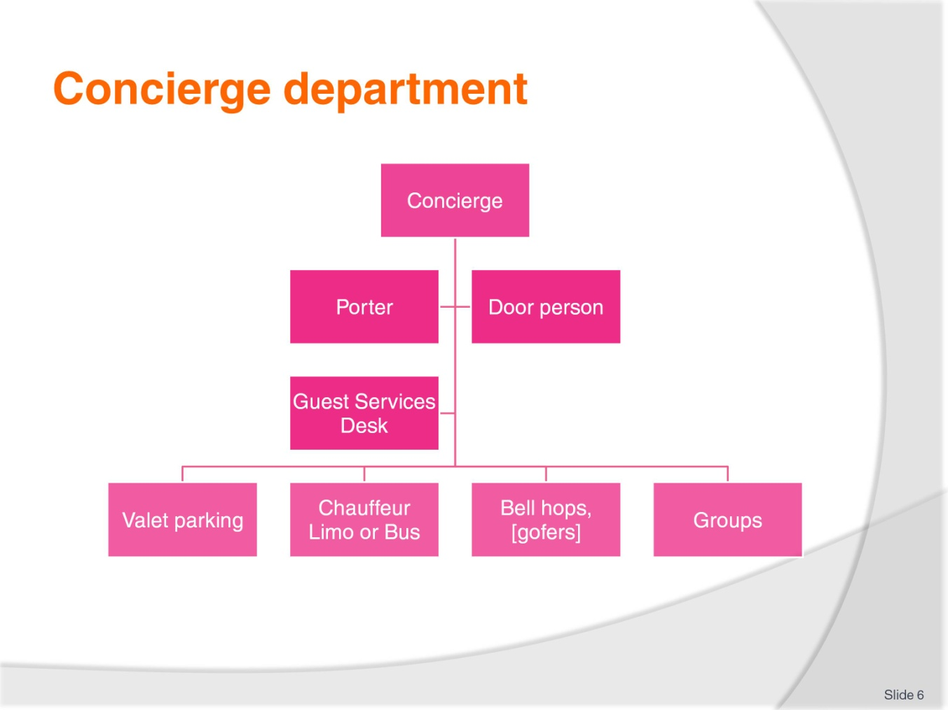
Slide No | Trainer Notes
 | Trainer to explain the Concierge department diagram.

Slide
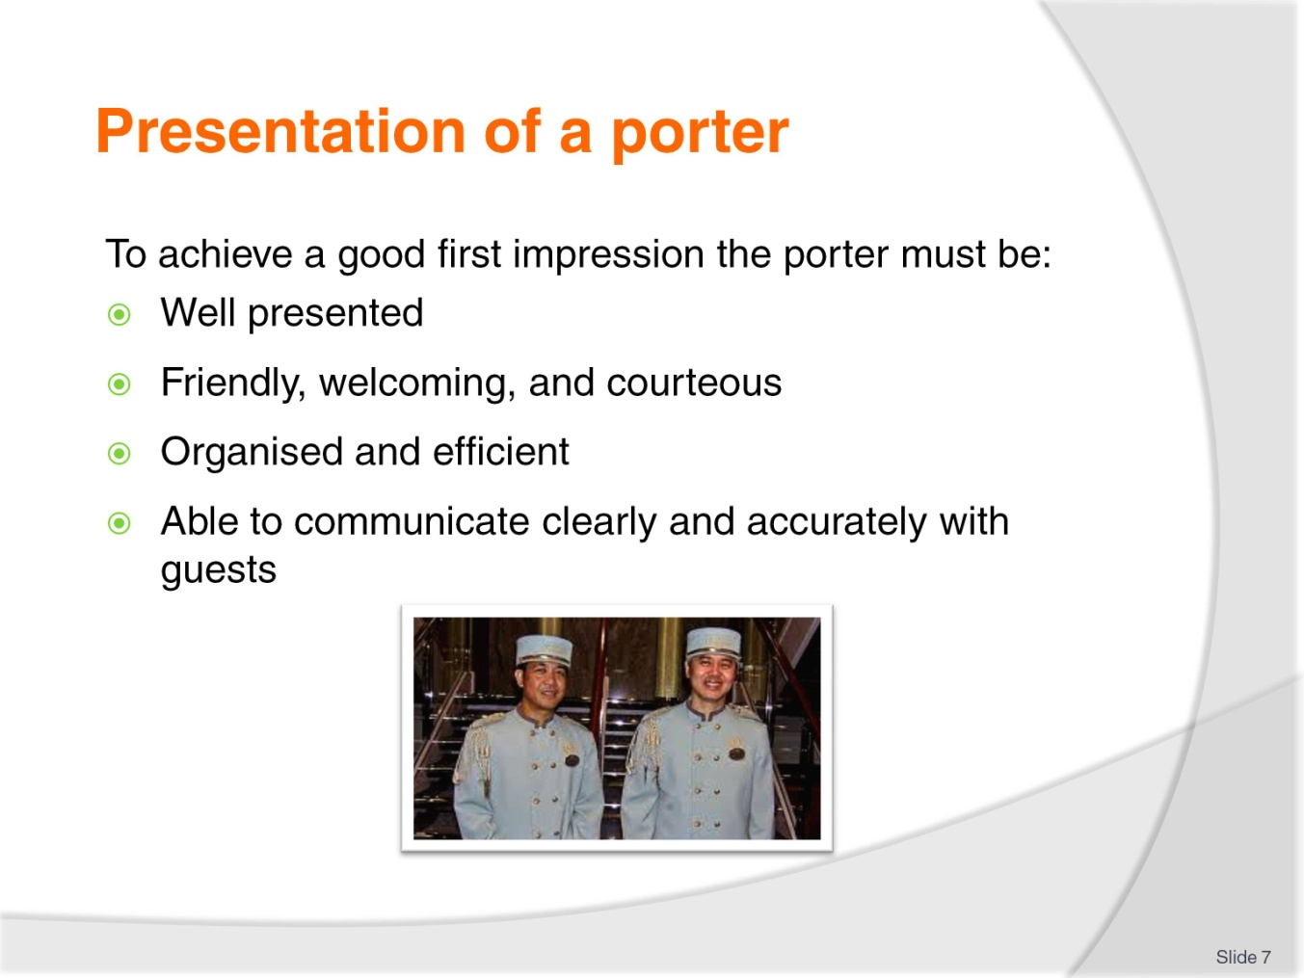
Slide No | Trainer Notes
The porter is often the first point of contact for the guest when arriving at an accommodation establishment.
It is therefore important for the porter to create a good first impression.
To achieve a good first impression the porter must be:
Well presented
Friendly, welcoming, and courteous
Organised and efficient
Able to communicate clearly and accurately with the guests.
A porter’s presentation will have a lasting impression on the guest and it is important that this impression be of the highest standard at all times.
Note the use of the words “at all times” –a porter must look as presentable five minutes before they finish, as they did when they started.
How staff stand and move reflects on the image of their personal presentation, be aware of posture, body language and the speed of movement.
A porter should move with dignity and purpose
Remember that a uniform, as well as personal grooming and deportment, completes the physical side of a porters professional and personal presentation.

Class discussion
Consider what type of uniform is required?
How will it vary from location and star rating?

Slide
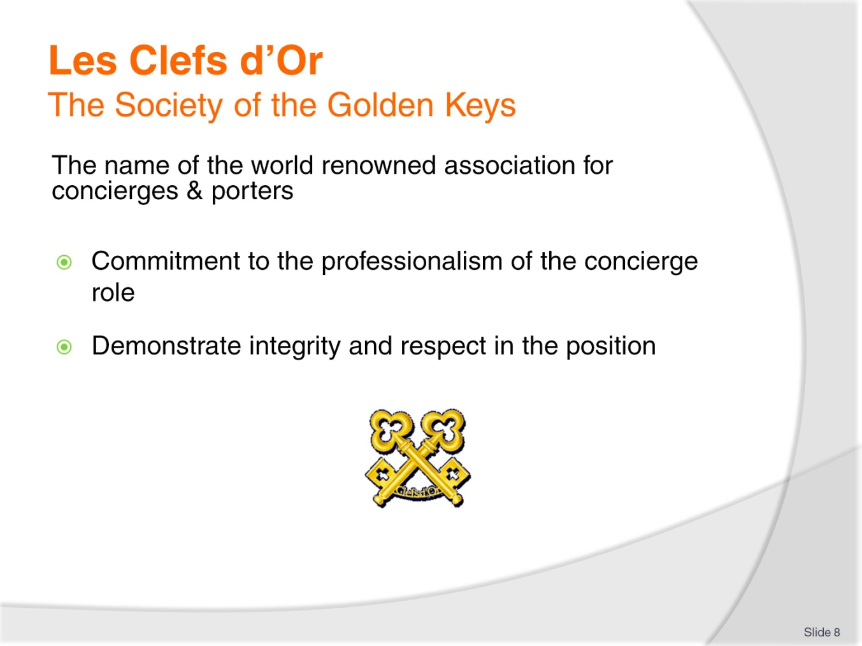
Slide No | Trainer Notes
As overlap in the roles of concierges and porters may often occur, take note of Les Clefs d’Or.
This society is a worldwide organisation of concierges. It was started in France in 1952 by the head porter of a large Parisian hotel with the aim of uniting all hotel porters in an association based on friendship, solidarity and fraternity.
Today, all around the world, the crossed keys are proudly worn on the lapels of concierges and their assistants.
Class activity
Why is a concierge who is a member of the Society of the Golden keys important to a Hotel’s prestige?

Slide
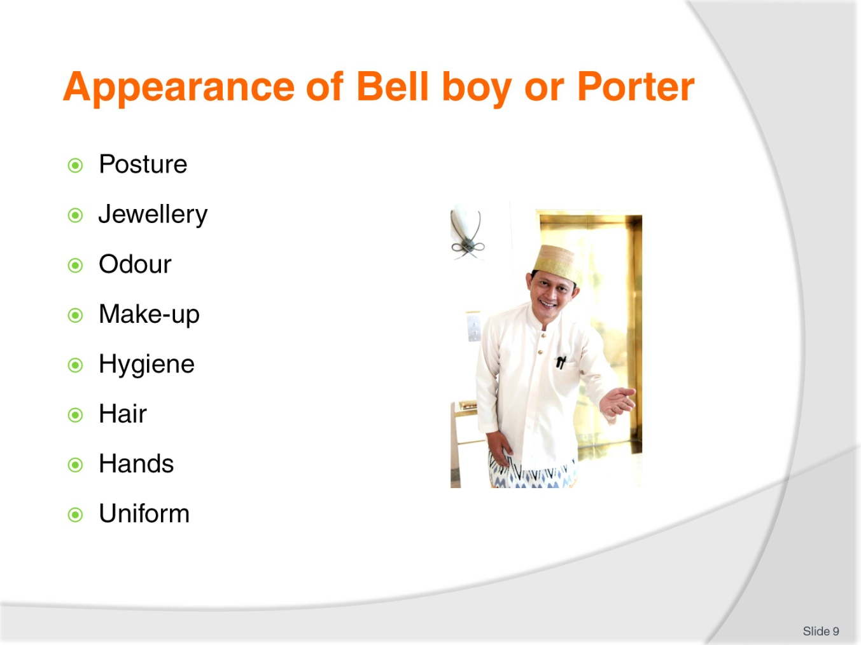
Slide No | Trainer Notes
Porters interact with other departments and external businesses:
Arranging hire cars, booking transport or tours
Booking tickets to the theatres, sporting venues or other entertainment
Confirming travel arrangements e.g. airline tickets
Make restaurant reservations and bookings
Deliver Mail and Messages.
The Concierge may also be responsible for lobby security and driveway supervision.
Grooming standard expected may include:
Good posture
Basic jewellery
Odour- Good dental health, Lightly-scented aftershave or perfume, Deodorant lightly scented
Make-up is kept natural
Hygiene, good personal hygiene habits, cuts and sores must be kept covered with a clean dressing
Hair - clean shaven or whiskers neatly trimmed
Hair - neat and tidy and tied back, if appropriate
Hands must be clean and well cared for at all times Manicured nails with natural coloured polish
Clean and pressed uniform, low heel, polished shoes.

Slide
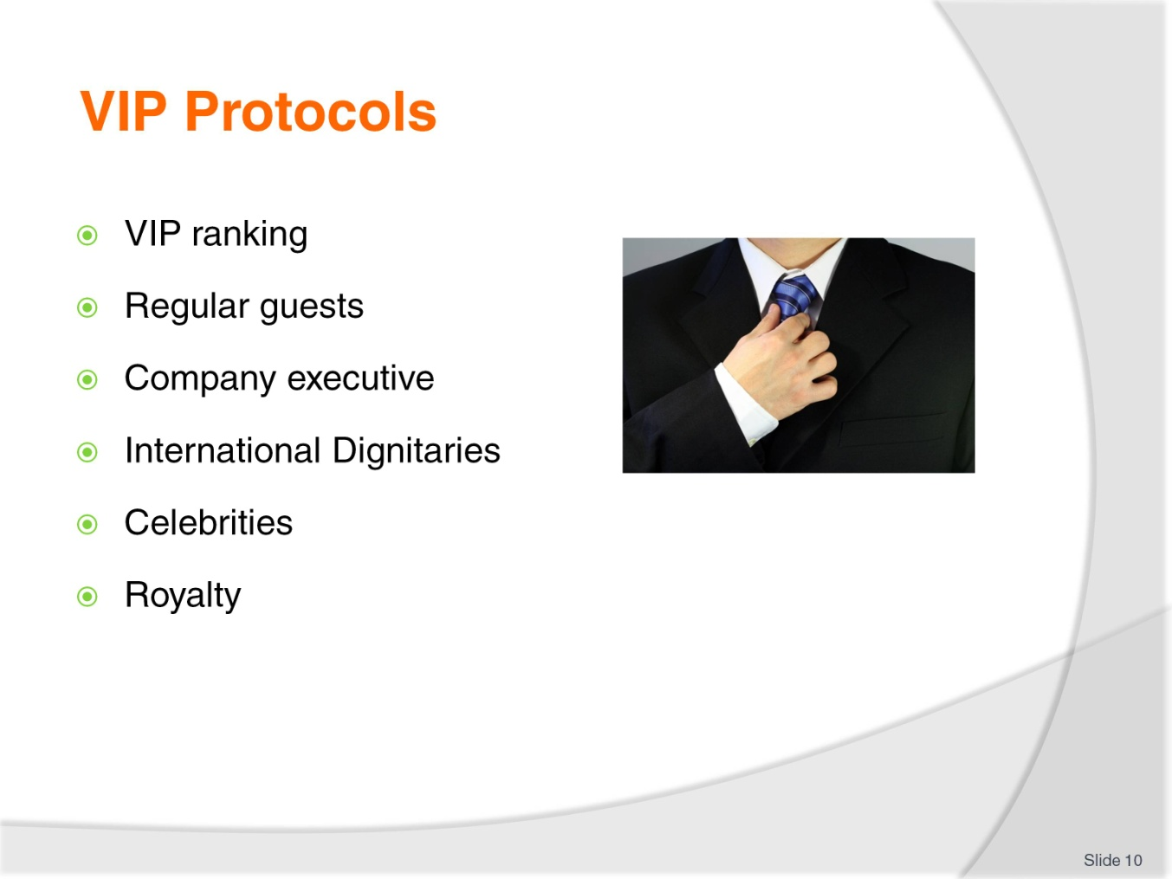
Slide No | Trainer Notes
VIPs are often ranked and include:
Regular guests, return guests will have rewards such as a fruit basket or upgrade
Home country government officials, heads of state, ministers , military leaders etc
Company executive, CEOs or managing directors, board members and business tycoons or owners
International or foreign dignitaries, heads of state, ministers , military leaders etc
Celebrities, actors, performers, athletes, notables
Titled people and royalty.
There may be a policy and protocols for addressing and escorting VIPs to their rooms. There will established practice and processes and these guests may arrive with their own staff and large amounts of luggage.

Slide
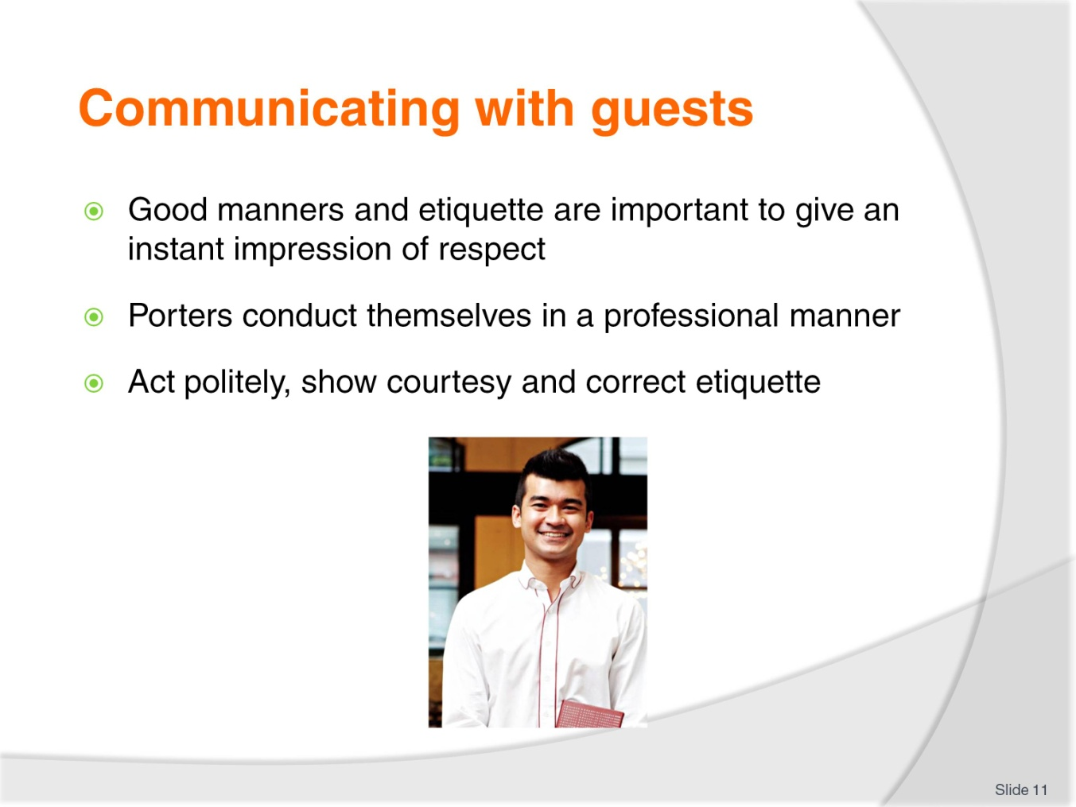
Slide No | Trainer Notes
The first impression of the establishment is often affected by the way the guest is greeted. The use of effective and appropriate non-verbal communication (body language).
It is critical that the message sent by the body language is in-keeping with the verbal message sent.
Class activity
Identify non-verbal gestures that could be used to direct guests to:
Greet the guests
Through the front door
Reception desk to check in
Into the lift or elevator.
Porters need to be well prepared and ready when greeting guests, able to give prompt and courteous service. Be aware of cultural and behavioural conventions including the use of honorific and social etiquette.
Establishing a relation and connection with the guest that is characterised by agreement and harmony is important. To achieve these outcomes when communicating with the guest, the valet must always:
Conduct themselves in a professional manner
Act politely
Show courtesy
Demonstrate correct etiquette at all times: etiquette can be described as manners, decorum and propriety – etiquette is the set of customary rules for behaviour in polite society
Speak clearly and concisely
Use the guest’s name at all times
Be truthful at all times
Exhibit a constant willingness to assist.
Maintaining confidentiality is an absolute requirement for a valet: it is 100% non-negotiable
Preparation for very important people (VIP) – which may involve the need for additional security, special gifts in the room, a guided tour of the property.
Class activity
Meet and greet practical role play with students establishing how to greet guests from different cultural background commonly travelling to your area as tourist or business.

Slide
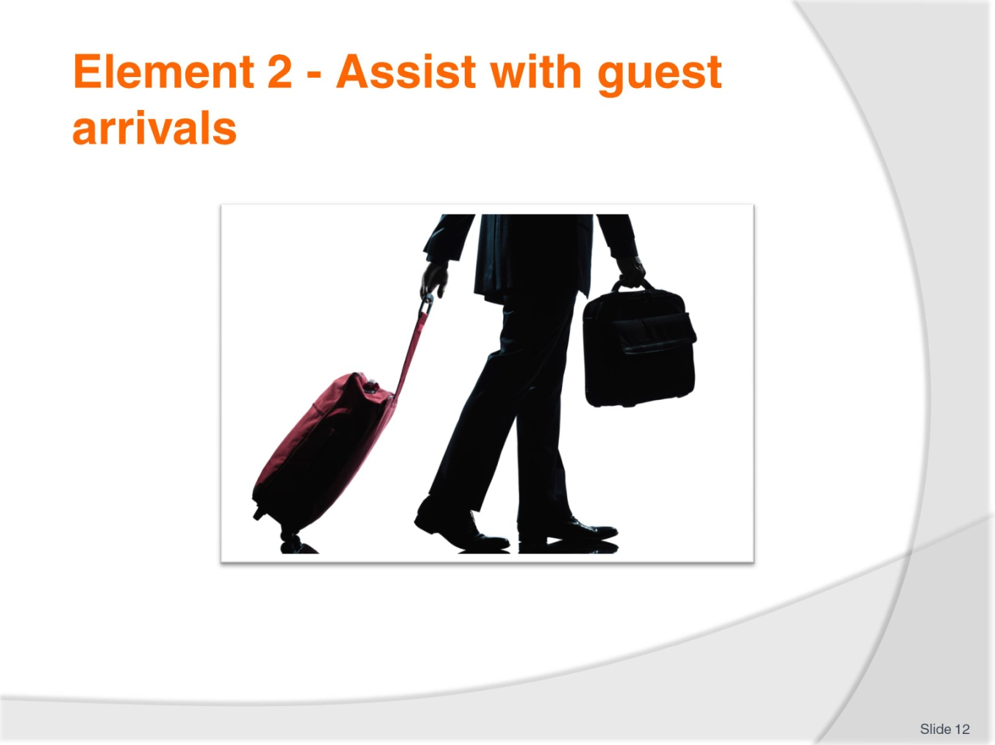
Slide No | Trainer Notes
 | Trainer introduces Element 2 - Assist with guest arrivals.

Slide
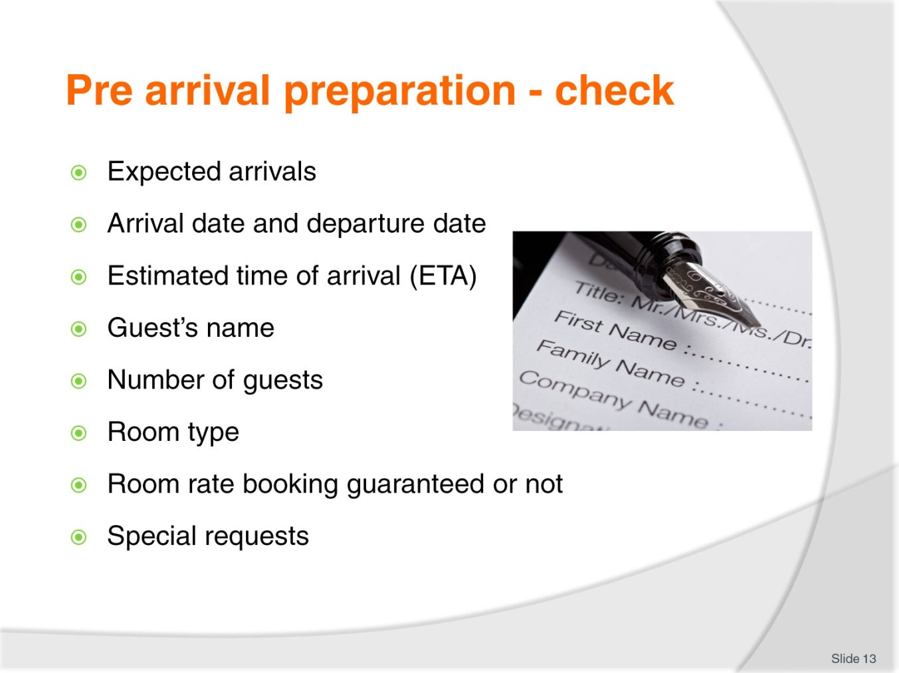
Slide No | Trainer Notes
Accommodation establishments generally have an Arrivals List.
The Arrivals List provides information to many departments, one of which is uniformed Staff, where it assists the porter in efficiently completing his or her tasks.
Whether the Arrivals List is manually or computer generated, the information found on it must always be treated in the strictest of confidence and should never be left unattended for public viewing.
Information found on an Arrivals List may vary from establishment to establishment, but can be expected to include:
Arrival date
Departure date
Estimated time of arrival (ETA)
Estimated time of departure (ETD)
Guest’s name
Number of guests
Room type
Room rate
Booking guaranteed or not
Special requests.
The Arrivals List is a necessary tool in the planning undertaken to receive guests.
It helps to inform management and staff as follows:
Staffing Levels – determining the number of porters required to meet shift demands
Planning of daily tasks – identifying the busy versus quiet times
Prepare for group arrivals – such as tours
Preparation of special requests – which may include items such as preparing for guests with a physical disability, a request for champagne on arrival in the room, a fruit platter, or a cot in the room
Organising luggage storage areas – especially for large groups of guests who may be on a tour, or who have all come off a recently landed plane.

Slide
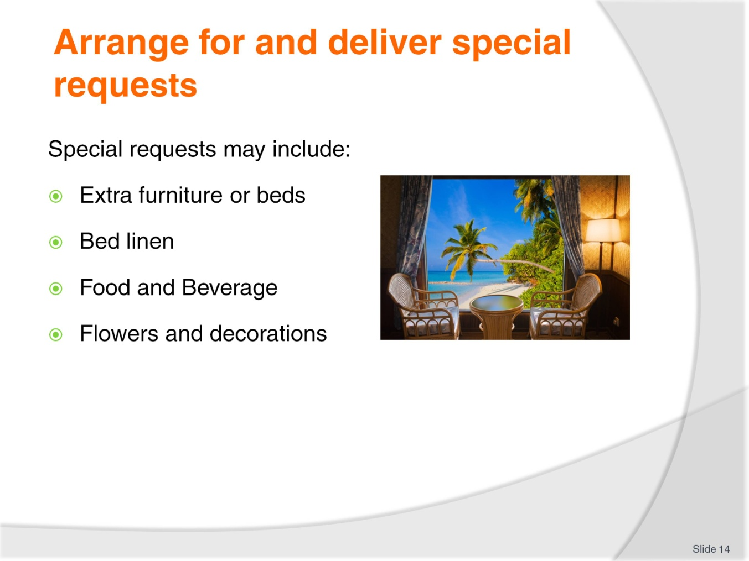
Slide No | Trainer Notes
The front office usually takes these special requests, with the original booking of the room or face-to-face with guests at check in or during their stay. The actual filling of these special requests requires a team effort and frequently it is the porter who is required to assist in ensuring special requests are fulfilled in accordance with requirements and establishment procedure and policies.
Use the internet to check the special requirements published for entertainment celebrities.

Slide
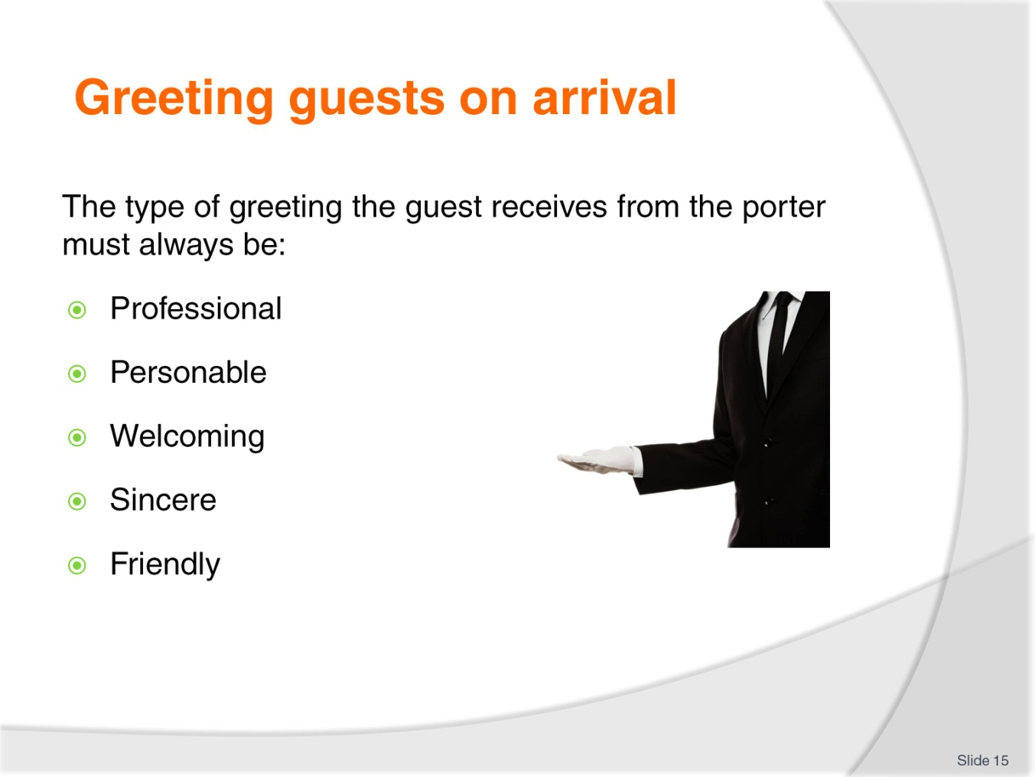
Slide No | Trainer Notes
The porter should ensure every guest receives a welcoming and professional greeting when arriving at the establishment.
Remember that the porter is usually the first representative of the establishment who meets face-to-face with the guest and this meeting can therefore have a lasting impression.
The moment the porter identifies a guest, they should immediately acknowledge them and not wait for the guest to make the first move.
The type of greeting the guest receives from the porter must always be:
Professional
Personable
Welcoming
Sincere
Friendly.
In all instances, the verbal greeting/welcome offered must conform to any establishment policies or directives, but will generally contain:
The establishment’s name
The guest’s name or title if appropriate
An offer of assistance.
The porter’s desk – or the “bell desk” as it is also known because it traditionally has a bell to summon portering staff – is usually strategically positioned in the lobby.
This is so the porter has a clear view of the entrance to enable them time to prepare themselves to greet guests, and so guests can also be seen by the reception staff in case they are needed: this arrangement also provides good security as a spin-off benefit.
Once the guests have been greeted, they should be directed to the reception area to register, as this is a legal requirement.
The porter will assist guests with their luggage and walk with them to the reception area. Once there, the porter should introduce the guest to the reception staff, if the guests’ names are known.
On other occasions, the porter will only guide the guests in the direction of the reception, while remaining at their post.

Slide
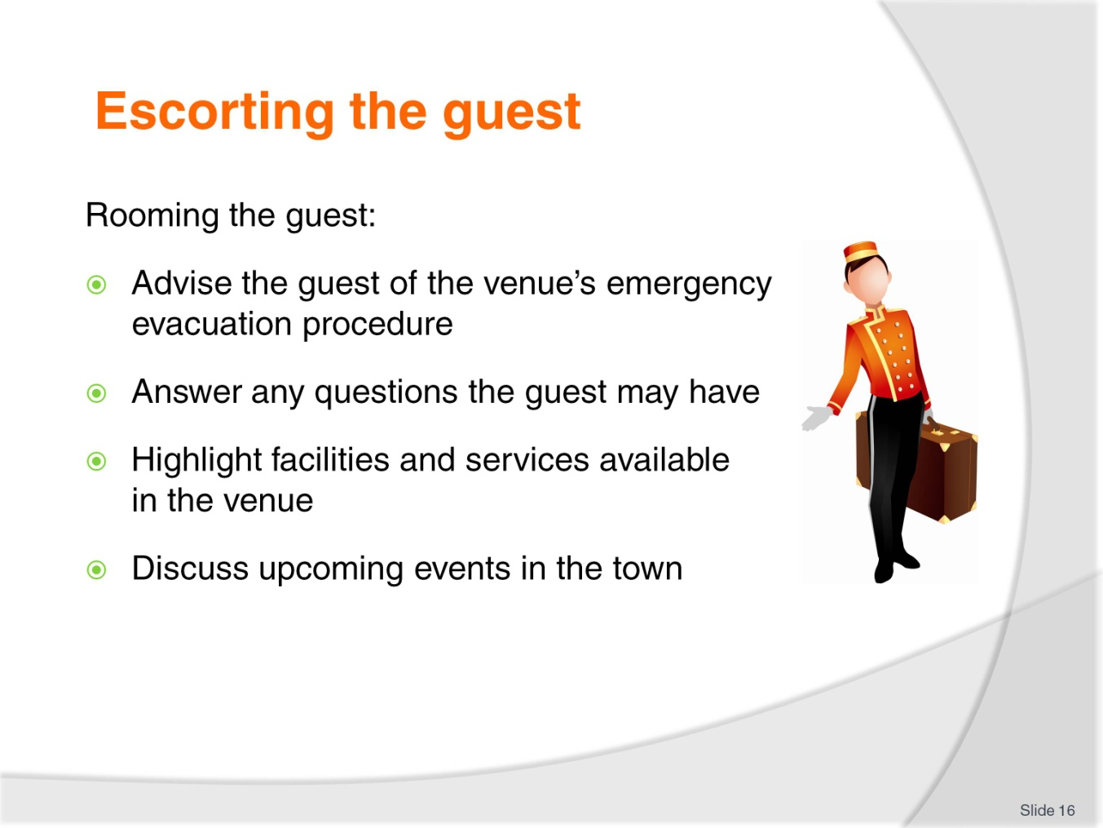
Slide No | Trainer Notes
Escorting guests to their rooms is an important role played by the porter.
It allows the porter time to:
Interact with the guest
Provide them with information about establishment facilities
Sell the restaurants, bars, spa, other hotel facilities
Provide details of tourist attractions, thus encouraging the guests to stay an extra night.
Once check-in has been completed, the porter receives the room key from the receptionist, collects guest luggage, and then escorts the guests to their room.
When escorting the guest to their room, remember to:
Speak clearly and concisely
Answer questions accurately, or inform the guest that you will seek out the answer and get back to them
Be courteous and polite
Never voice your opinions on issues unrelated to the establishment
Keep the conversation professional and on a positive note
Walk at a comfortable pace to suit the guest
Ascertain if this is the guest’s first time at the hotel: if it is, try to sell facilities of the property.

Slide
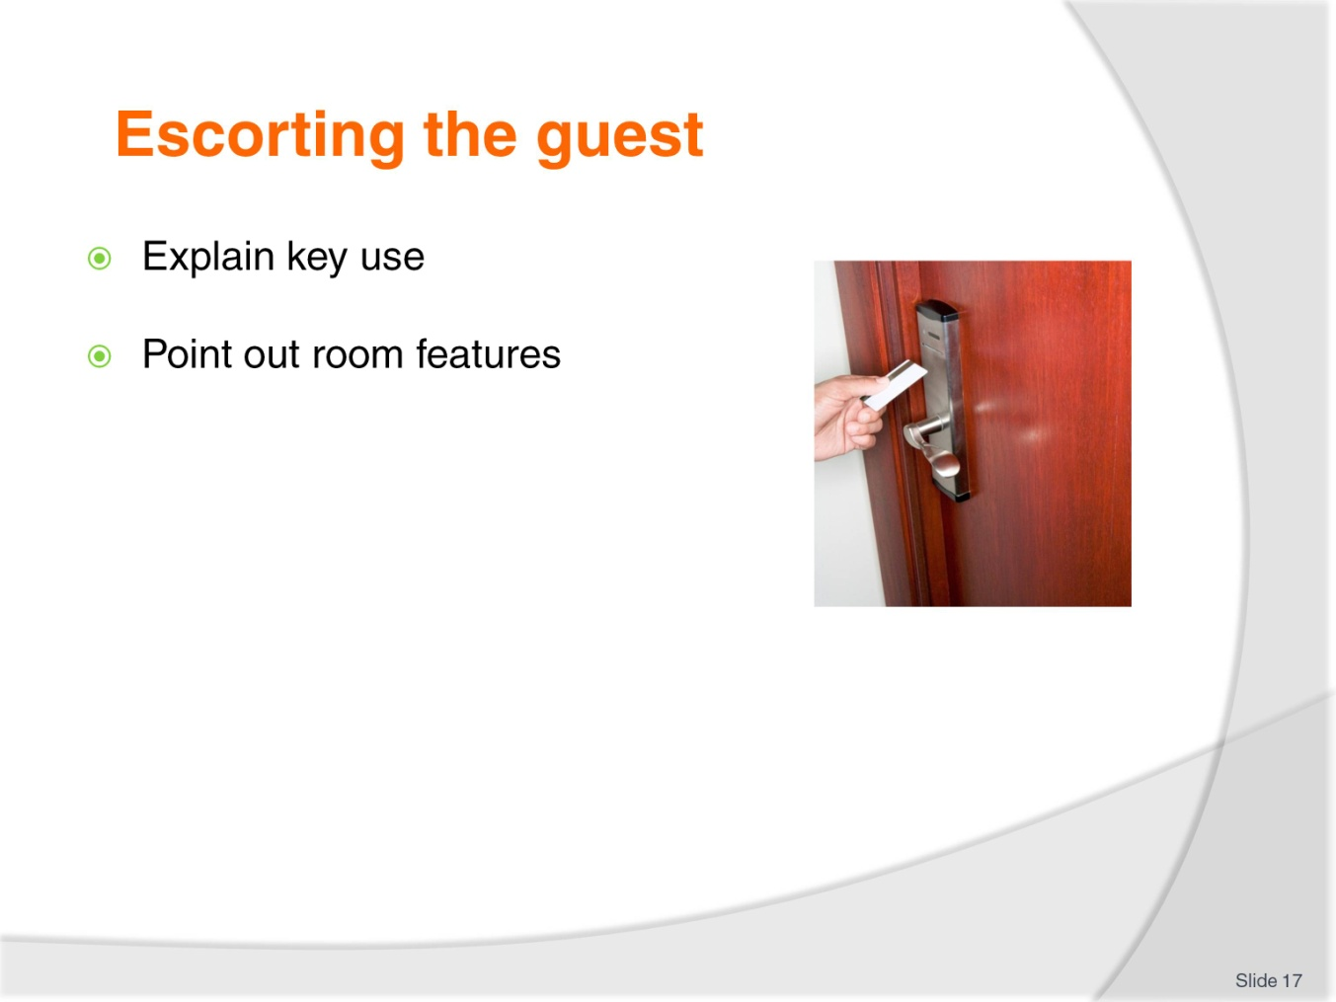
Slide No | Trainer Notes
Use the internet or YouTube to view room entry and different types of keys.
List room features:
Environmental control- heating and cooling
In house movies
Mini bar
Telephone
Compendium.

Slide
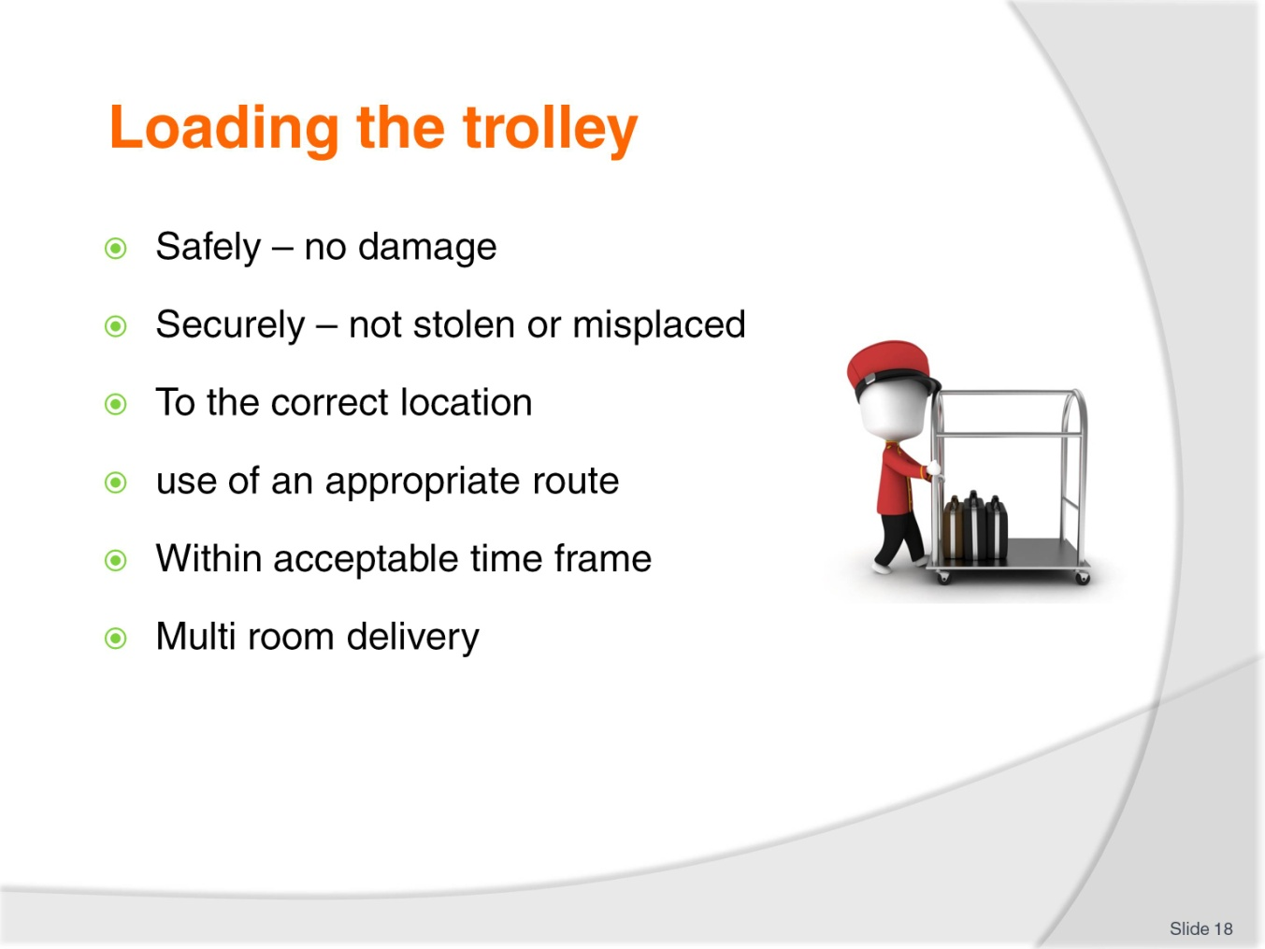
Slide No | Trainer Notes
Throughout a shift there will be many times when the porter must assist guests with their luggage.
Luggage may have to be removed from the boot of a car or from the compartments in a tour bus. Luggage should also be treated as an item of great value and never be left unattended, particularly outside the hotel entrance.
Occupational Safety and Health; Luggage can be heavy – sometimes very, very, heavy – and therefore the porter must be aware of some basic occupational safety and health issues regarding handling luggage, including:
Test the weight of bags before lifting – give them a test lift
Adopt the correct posture for lifting
Keep the back straight
Bend the knees
Lift the luggage.
Use an approved trolley if luggage is too heavy to lift comfortably and correctly.
If more than one item is to be placed on the trolley, the heaviest bags should be placed on the bottom and the lighter ones near the top.
If an item is too heavy to pick up, the vertical trolley should be used as the porter will not have to personally lift the bags.

In some establishments, specific routes for the trolleyed transportation of guest luggage have been identified: these should be adhered to where they apply.
Likewise, some establishments have procedures for where certain luggage should be placed within rooms – articles on hangers may have to be hung up, suitcases to be put onto the appropriate racks, briefcases next to the bed, and so on: these must be adhered to with every guest in every room, unless the guest requests something else.

Slide
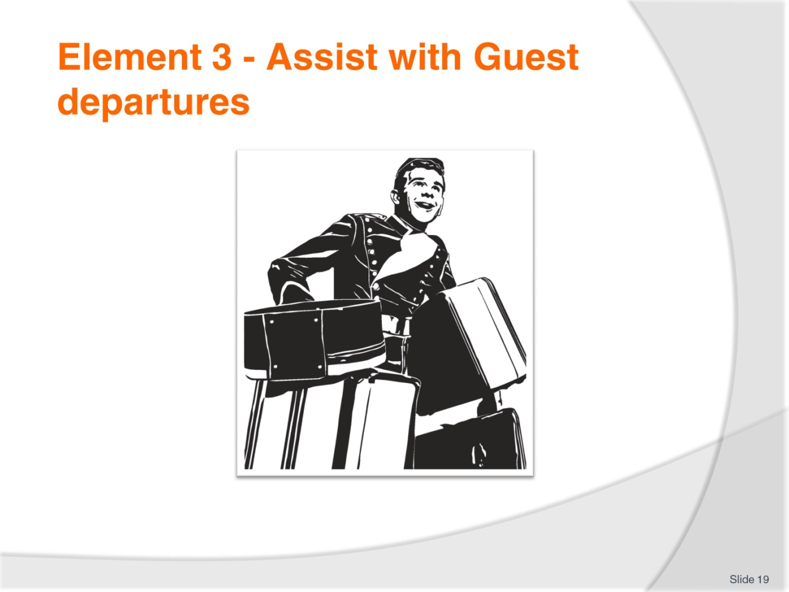
Slide No | Trainer Notes
 | Trainer introduces Element 3 - Assist with Guest departures.

Slide
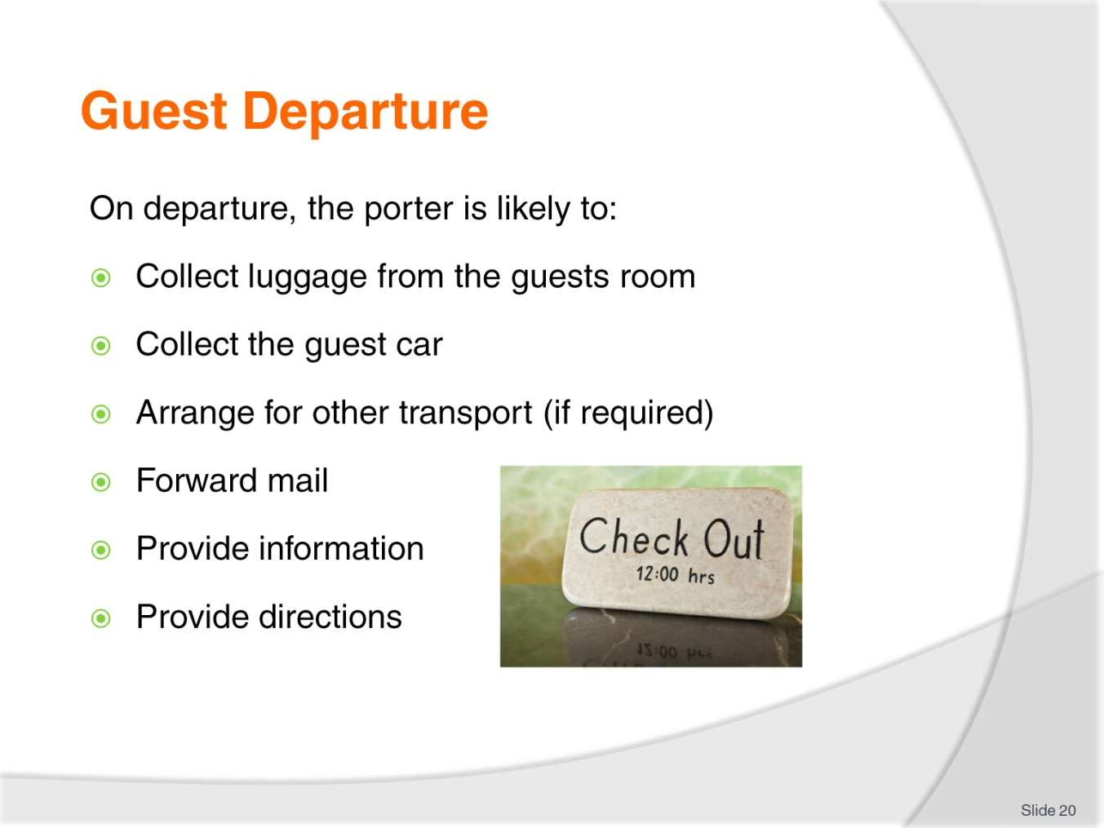
Slide No | Trainer Notes
When a guest is ready to check-out of their room, the porter will be required to assist the guest with their luggage.
The porter will usually be advised as to how much luggage has to be moved and the approximate weight of the luggage. A trolley may frequently be needed.
The porter should arrive at the room in plenty of time to ensure that guests achieve their stated aim – if there is one (such as catching a certain plane, being away by a certain time, etc): it must be remembered that guests can get very anxious at check-out too.
Upon arriving at the guest’s room, the porter should knock on the guest’s door and announce him or herself.
On being invited into the room, the porter should inquire as to the whereabouts of the luggage and the number of items, some will be quite obvious but some might be in the bedroom, the lounge or even the bathroom, also check for forgotten items. In some cases, where there are shops within the complex, guests may even want you stop by one of the shops to pick up a package.
Sometimes the guest will accompany the porter to the reception area, where the guest will check-out. The porter will then move the guest’s luggage to a private car, taxi, or tour bus.
On other occasions, the porter will be asked to take the luggage down to the reception area or storage area and the guest will check-out later.

In this case, the porter needs to tag the luggage and store it in the Porter’s Room or the Luggage Room. In some properties the room has bay numbers, e.g., Bay One, Bay Two etc. and this number is recorded on the guest’s luggage tag for easy retrieval upon check-out.
The rules about transporting luggage – mentioned earlier – apply at this phase of the guest’s stay too.

Slide
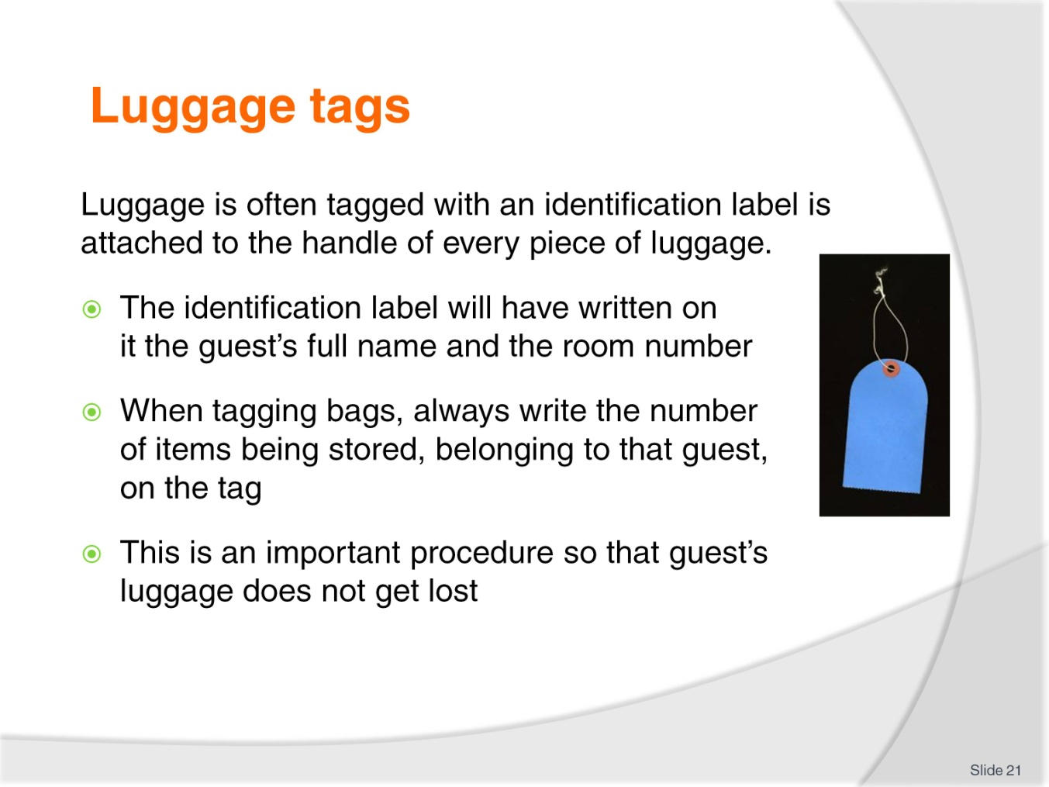
Slide No | Trainer Notes
Most accommodation establishments have luggage labels.
The tag will indicate:
Whose luggage it is (guest name)
Guests room number
Group name (if appropriate)
Number of pieces
Type of luggage.
The porter should always use luggage labels to write the guest’s name and room number on as soon as this is known. The label should then be attached immediately to the guest’s luggage.
It is most important for the porter to ensure that all luggages are labelled accurately.
Sending the wrong luggage to the wrong room causes annoyance, poor guest relations, and embarrassment and has the potential to lead to theft, and breaches of privacy.
Luggage itself should never be actually marked.
Luggage should have a tag attached. This tag may be a two-part type where one-half of the tag is attached to the luggage, and the other portion is given to the guest for them to use when claiming the luggage.

Other tags simply register the name of the guest whose luggage it is, together with the total number of items stored: in some cases the guest is asked to provide an approximate time of pick-up so that the porter can determine where in the Luggage Room to physically store the items.
Some establishments utilise an alpha storage system whereby items are stored in alphabetical order (using the guest’s surname as the indicative letter); some will use a system based on given pick-up times.
Class activity
Design a luggage tag and role play with students greeting guests and filling out and attaching the tag to luggage items.

Slide
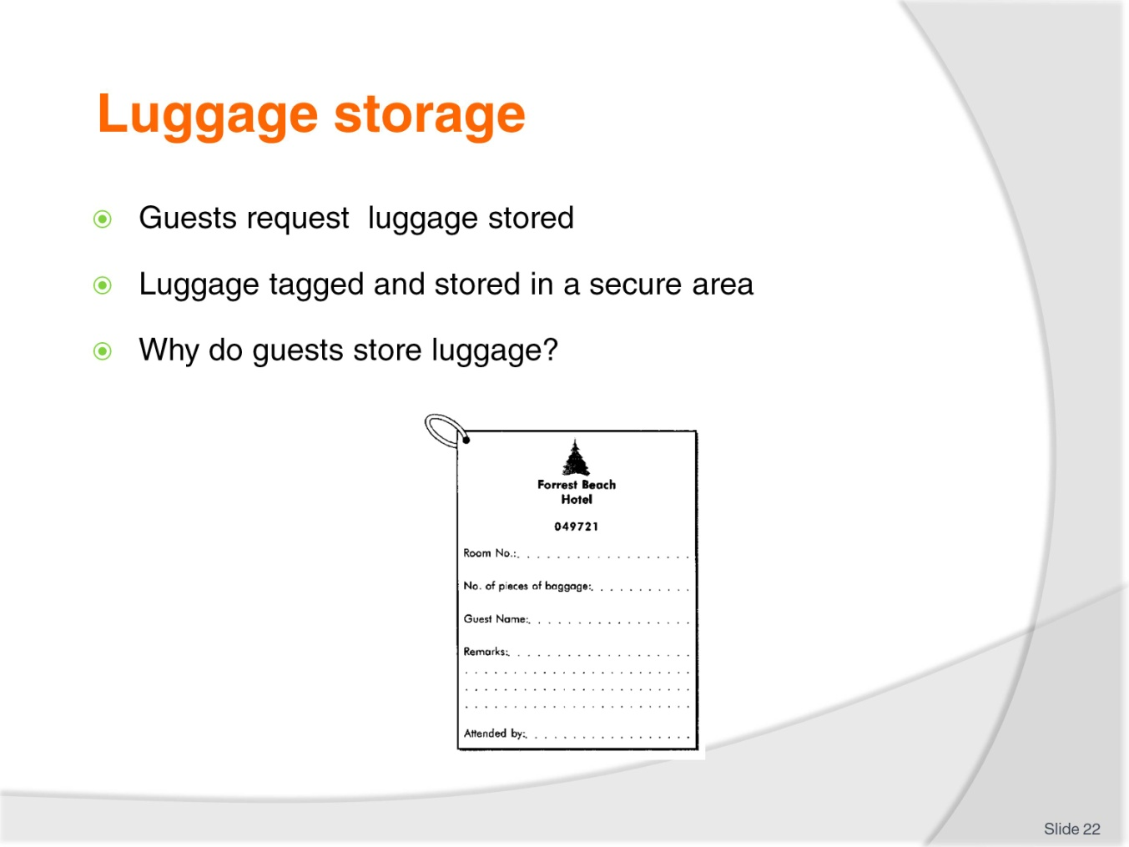
Slide No | Trainer Notes
In-house luggage storage systems vary between establishments, usually in terms of their size, location and documentation used.
Luggage storage systems (Luggage Rooms) are places where guests can store their luggage before they are roomed, or after they have departed their room.
In some cases, the guest may have arrived at, say 6am, only to find there is no vacant room: guests are still occupying them, and/or dirty rooms have not been cleaned and notified as “room ready”. In such cases, the establishment may register the guest (because they know a room will become vacant for them), offer them a free breakfast while they wait, and store their tagged luggage in the Luggage Room.
The first appropriate room that becomes vacant will be allocated to them, the porter notified, and the luggage delivered.
In another example, a guest may depart their room at 9.45am and be leaving town that evening at 6pm on a cruise: they may ask that their luggage is kept for them until 2pm to enable them to go and do some shopping before they pick it up and head off to the wharf.
The Luggage Room would be used for this type of safe storage
Enterprise procedures for storing items in the Luggage Room focus on security
Each item is tagged and contains the guest’s name and usually the total number of items lodged for storage
Some form of documentation – perhaps half of a tear-off slip – is given to the guest to facilitate the retrieval of the luggage
When the guest returns to collect their luggage they are required to provide identification before being supplied with their luggage
Where identification has been lost – management should be called immediately to resolve the problem
Luggage will be transported by porters as required – either to the room, or to the external pick-up area/car park.
At the time of arrival, a guest’s room may not be ready. To give the guest the freedom to leave the venue without the inconvenience of holding onto their luggage, the venue will store it for them.
Guest may not require some items in their Room, e.g. sporting equipment, Items not needed for this section of the guests journey
Conversely, at the time of departure, the guest may be required to vacate the room by 11.00 am but not due to leave the town until that evening. Again, the venue will store the guest’s luggage for them until required.

Slide
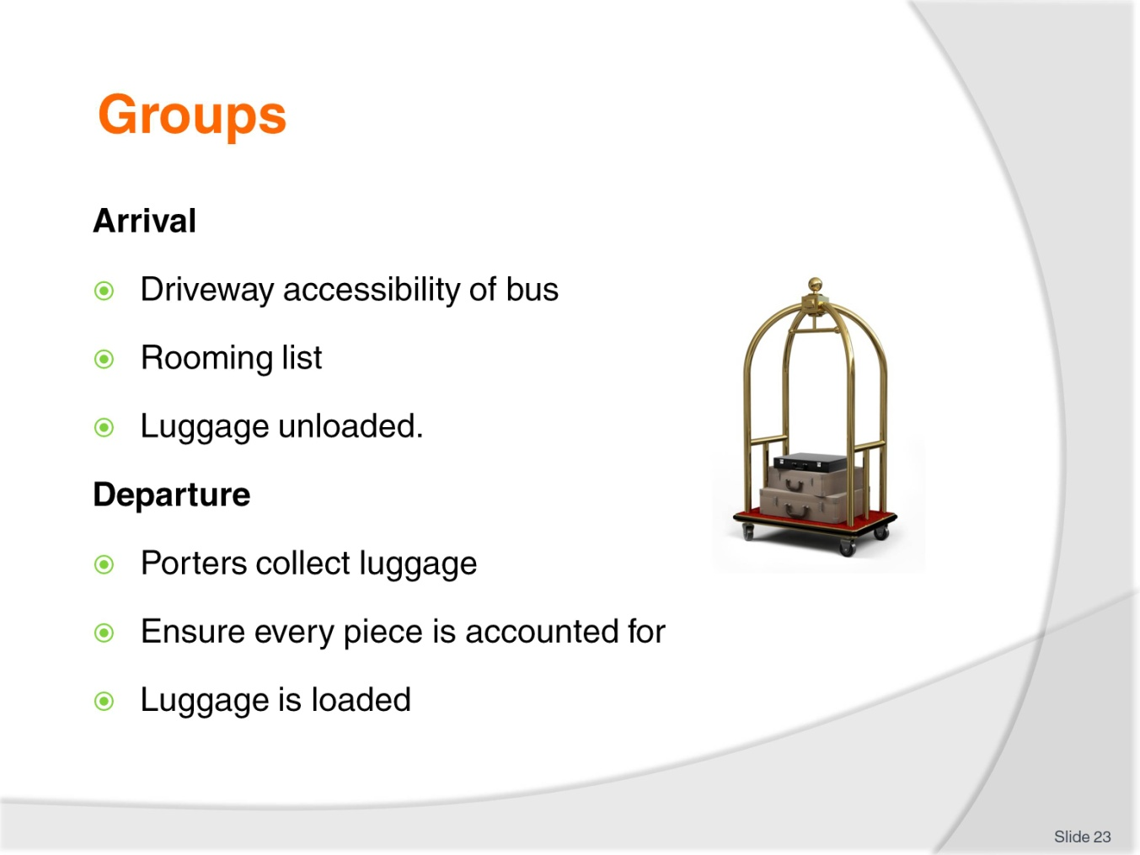
Slide No | Trainer Notes
Groups arrival
Bus arrives and luggage is unloaded and transported by the driver and/or porter to designated area. (such as a special group check-in reception area)
The porter counts and records the luggage on the group file
Receptionist checks Rooming Lists and all relevant information for correctness and smooth check-in process
Luggage is tagged by the porter
Porter obtains Rooming List and places room numbers on tags
Luggage is distributed to the different floors/rooms.
Groups departure
Shortly before the group’s departure, the porter collects luggage from rooms at allocated times (some hotels prefer luggage to be left outside the room for time saving reasons)
Porters collect luggage
Luggage is counted and checked against Rooming List to ensure every piece is accounted for
Luggage is loaded onto the bus by porters.

Where a group is storing luggage, the marking and storing will take this into account – perhaps by using a colour-coded tag – this is not only a benefit to the guests but also speeds things up for porters when they are trying to identify appropriate luggage.
In some establishments, porters may be specifically tasked to deal with luggage from a group: they are dedicated to this task and, as such, can render more personal, thorough and careful service.
If a large group is checking out and there is not enough space in the Porter’s Room or Luggage Room, then the following three possibilities may apply:
Luggage is placed in a hotel room (it is called a hospitality room). Some establishments will charge 50% of the room rate for such a service
Baggage is positioned in one corner of the lobby and it is roped off. A thick rope goes through all the handles on the luggage so that nothing can go missing
Baggage is positioned in one corner of the lobby and it is netted. This is when a large net, similar to fishing net, is placed over the top of the luggage and secured tightly.

Slide
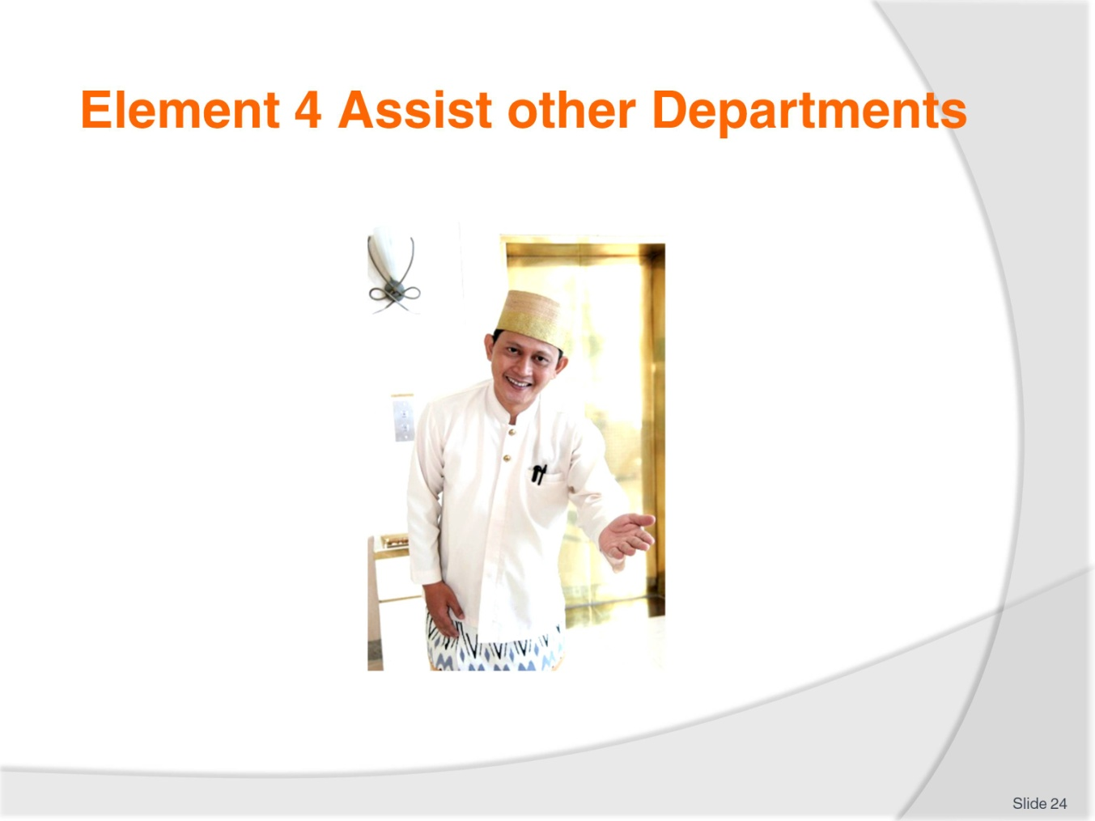
Slide No | Trainer Notes
 | Trainer introduces Element 4 - Assist other Departments.

Slide
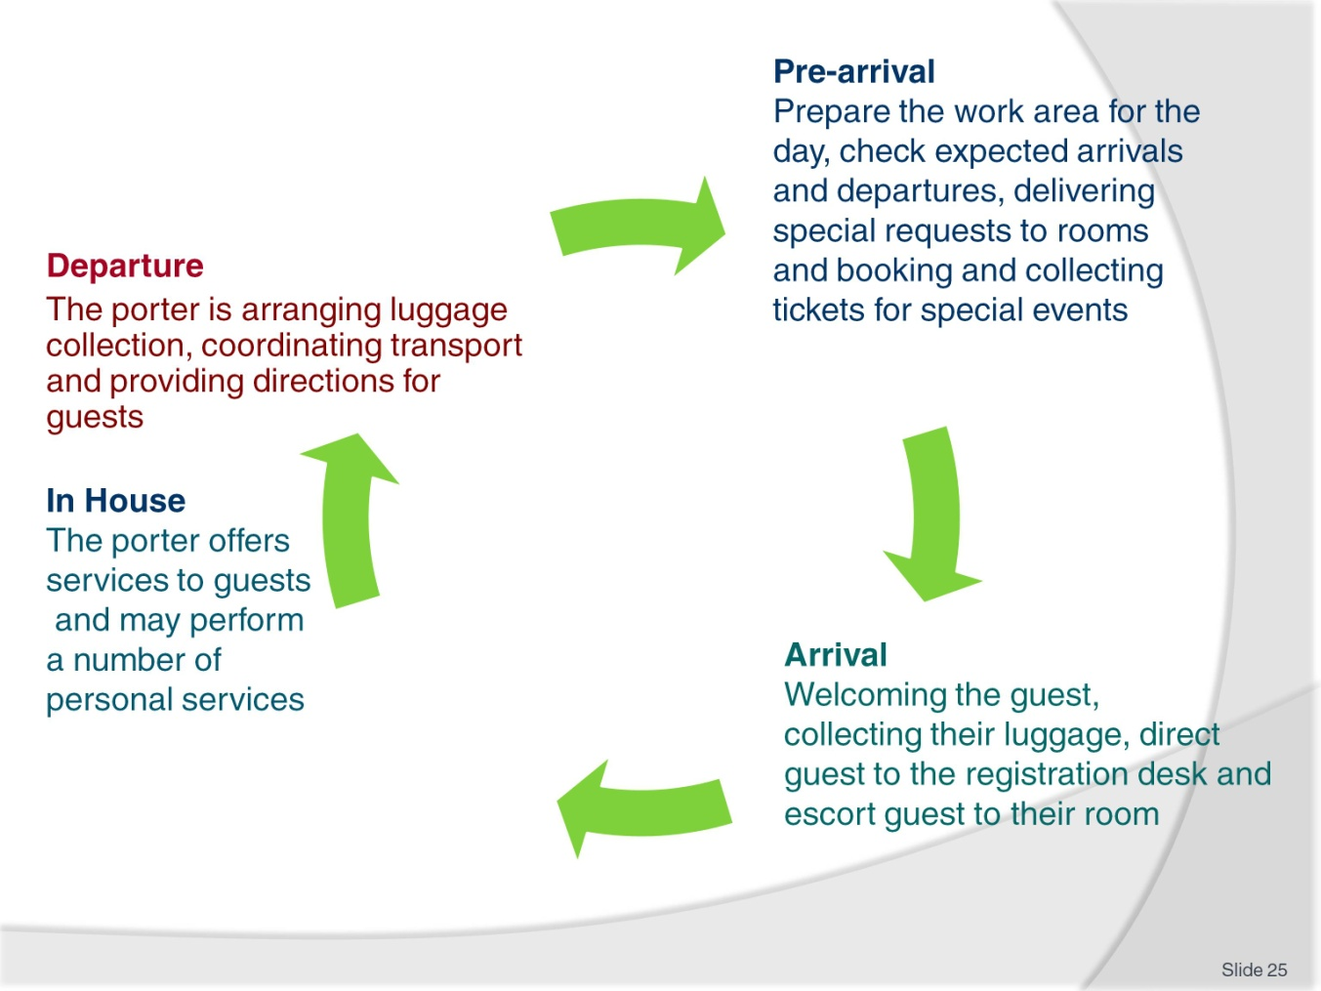
Slide No | Trainer Notes
Trainer explains the range of duties and interactions a porter has with a guest at all stages of the guest stay.
Revise the links with other departments.

Slide
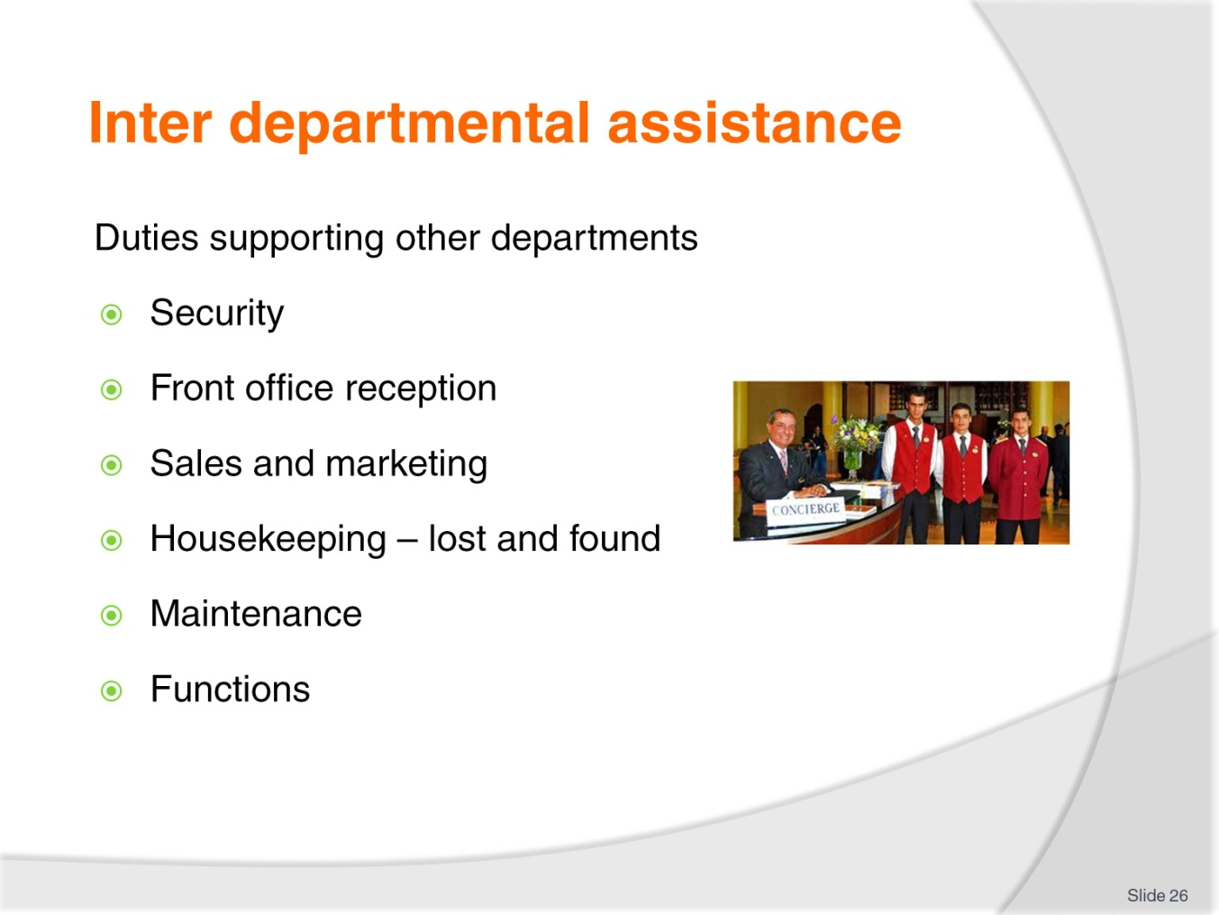
Slide No | Trainer Notes
Porters may be asked to perform other duties, in departments short of staff for example room service need to clear a large number of trays or trolleys.
Security- For VIPs or to secure group luggage or other guest property
Front office reception- Guests special requests, reports & messages. Collecting guests tickets or Visas
Sales and marketing- information and promotion of in-house services and special events
Housekeeping – lost and found, Room status, guest requests
Maintenance – replacement light bulbs or other items
Functions - in house events such as conferences.

Slide
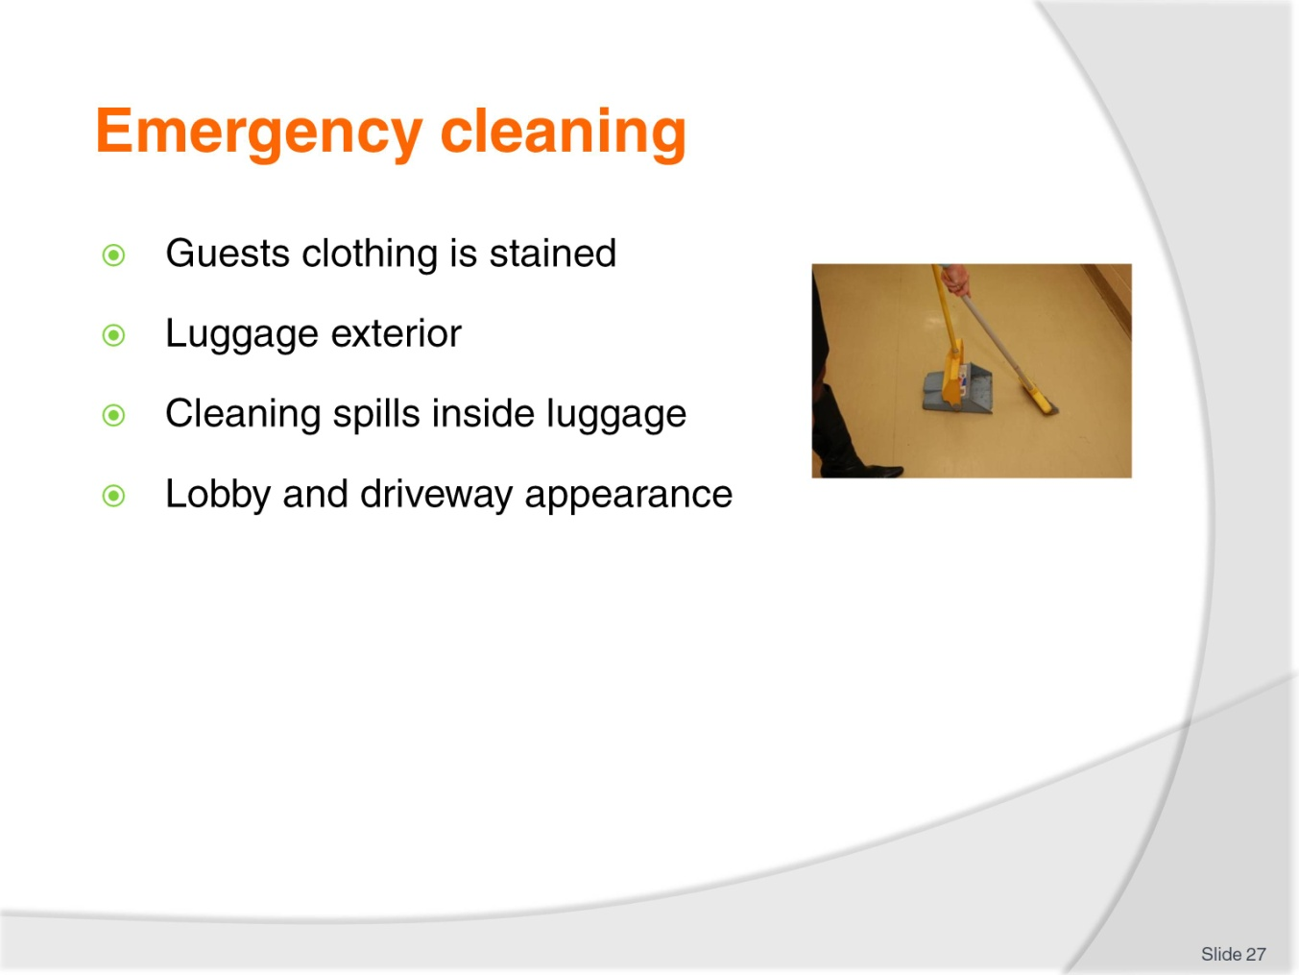
Slide No | Trainer Notes
Accidents leave clothing and other items stained and in need of cleaning.
The Hotel will keep contact details with specialist dry cleaners or fabric cleaners.
Some stains may be treated on site by Hotel staff for example Red wine spilt on a guests dress, or Chocolate or berry stains. If the guest has played a sport or participated in an outdoor activity Porters may have to clean a variety of dirt, mud or grass stains.
Hotel staff will have a reference resource on treatment of stains in an emergency.
Lobby and driveway appearance - Cleaning soil tracked in by guests, smokers’ ash or liquid spills.

Slide
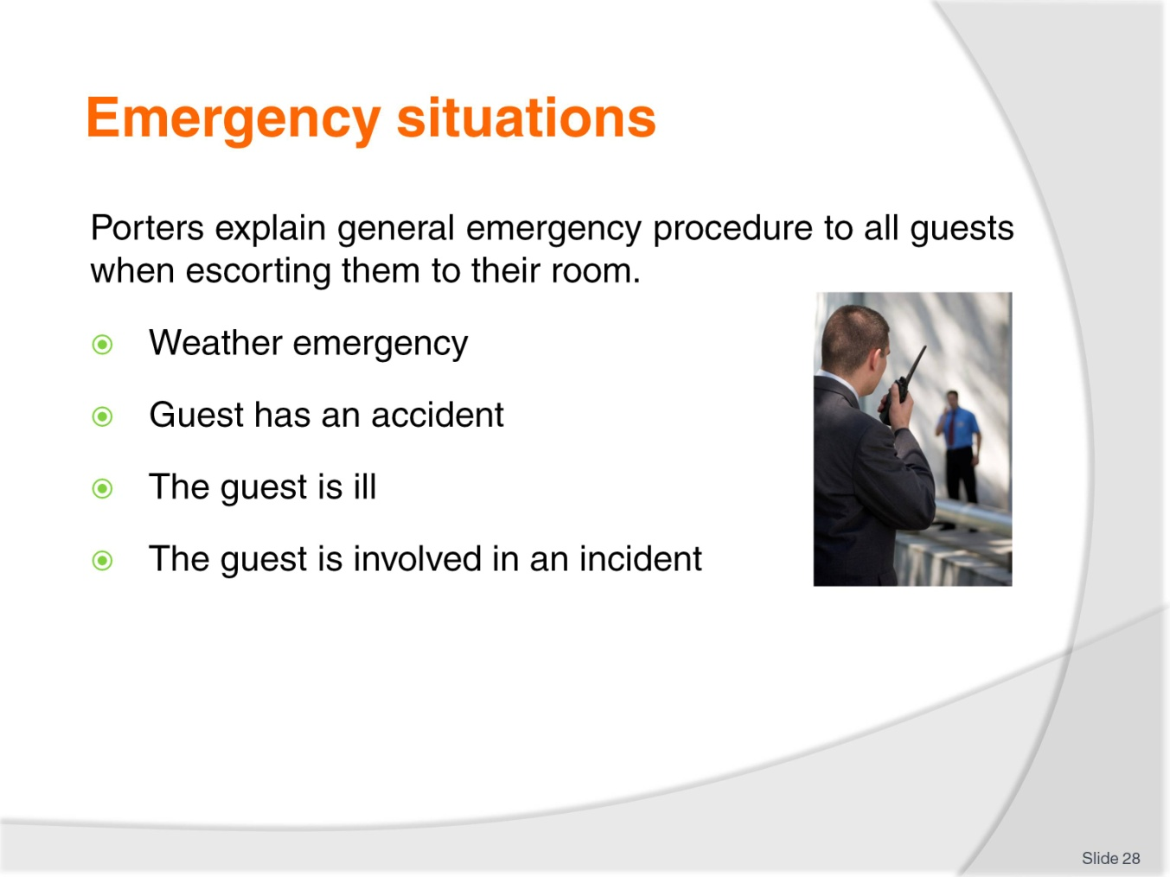
Slide No | Trainer Notes
The Hotel or resort would have staff trained in various levels of first aide and policies and procedures for staff to follow in case of emergency.
Porters, in keeping a reference file of information to assist in responding to any guest requests, have an extensive list of medical professionals including specialists, dentists, doctors, chiropractors, physiotherapists, sports therapists and also culturally applicable medical service.
All incidents will be recorded and logged following the establishment’s policies and procedures.

Slide
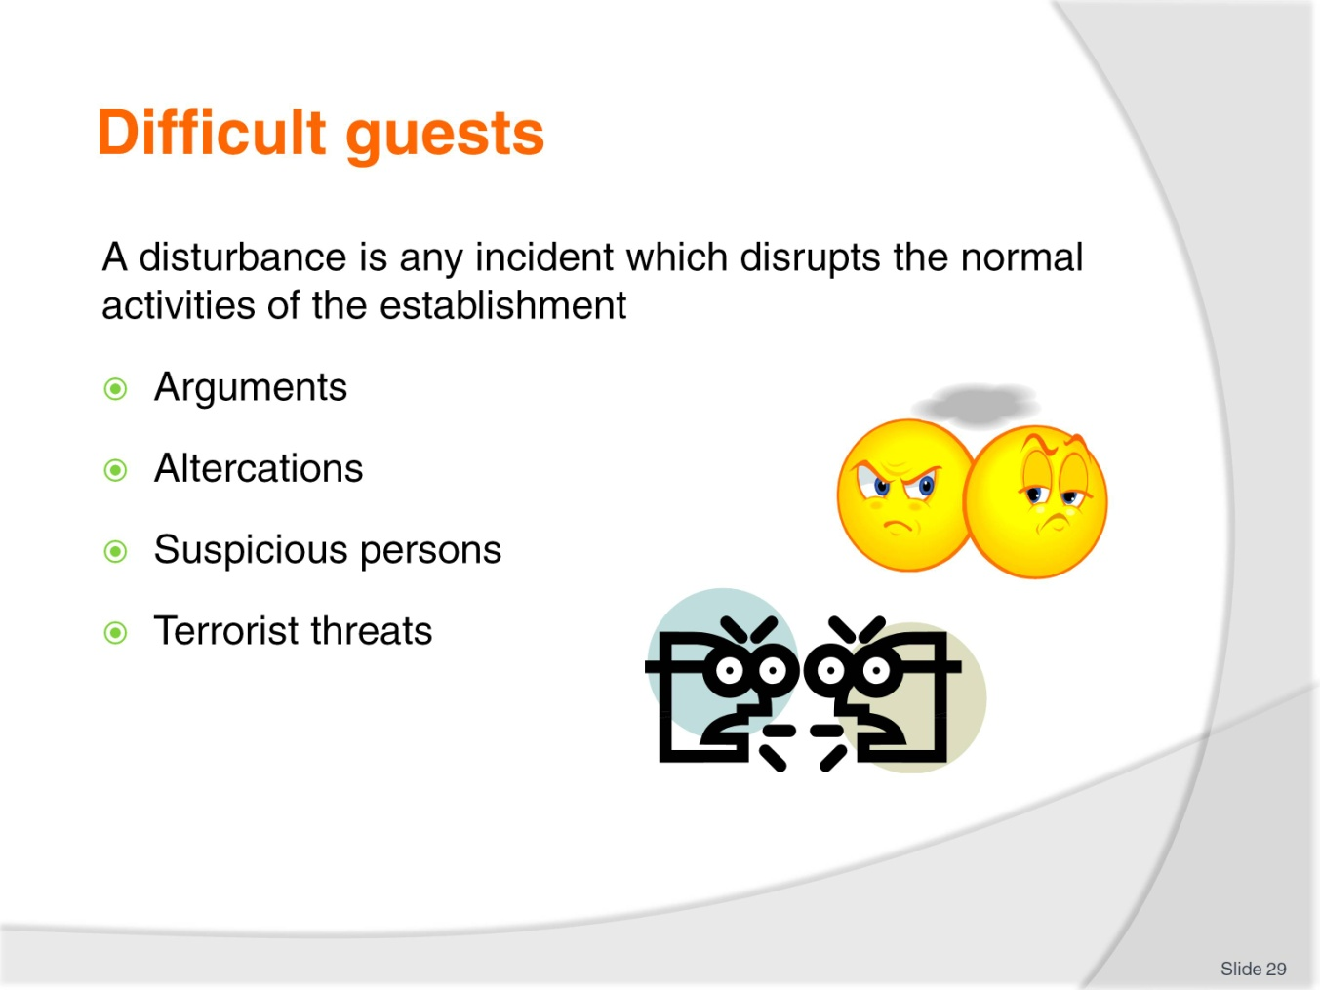
Slide No | Trainer Notes
The porter may be required to assist when a disturbance does occur.
A disturbance is any incident that interrupts the normal activities of the venue.
It may include:
Guests who are having an argument or altercations
Suspicious persons people who are out of place or acting strangely
Terrorist threats such as bomb scares, gunfire or threats.
A porter needs to be constantly alert to people who seem ‘out of place’, uncomfortable or suspicious.

Slide
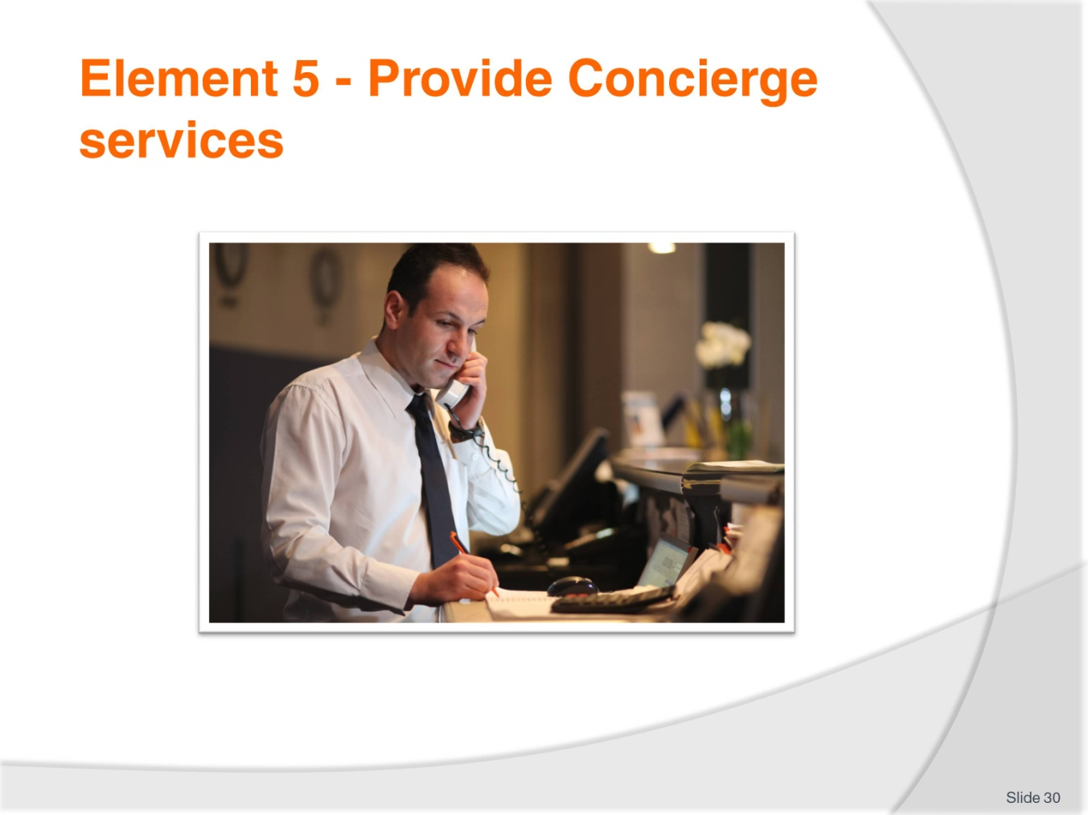
Slide No | Trainer Notes
 | Trainer introduces Element 5 - Provide Concierge services.

Slide
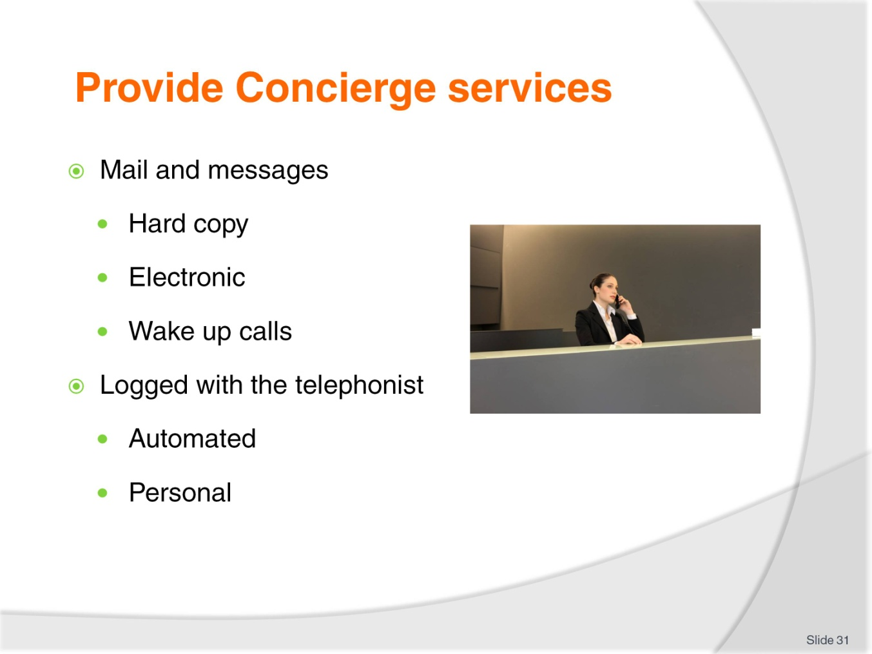
Slide No | Trainer Notes
Mail and messages types to be delivered include:
Snail mail, cards or promotional material, accounts,
Electronic accessible by the guest on the TV or telephone voice mail
Mail or messages may be received for:
Current guests
Future guests
Past guests.
For each there is a specific procedure to follow. All mail, parcels or messages must be time and date stamped and recorded in a mail received book.
Wake up calls
Depending on the Establishment ,The guest may prefer the option of having the wake-up call placed directly to the guest’s bedside phone, or the Butler or room service staff may take the wakeup call and personally knock on the guest’s door to awaken them usually with a morning service tray with a hot beverage or fruit juice.
Wake up calls can be organized through the Reception staff or the hotel telephonist who takes details of time and date of the request and at that time phones the guest s room to wake the guest up as this is a person to person call it may assist the wake up process if the guest explains the reason for the call for example a plane to catch or meeting to attend.
Some establishments have a direct computerized system wakeup call system. The guest logs the details of the wakeup call and an automated system rings and prompts the guest.
When booking a wakeup call the information should include the Guests name and room number, wake-up call time and sometimes purpose Include any snooze and recall times.
Class activity
Create a wakeup call sheet.

Slide
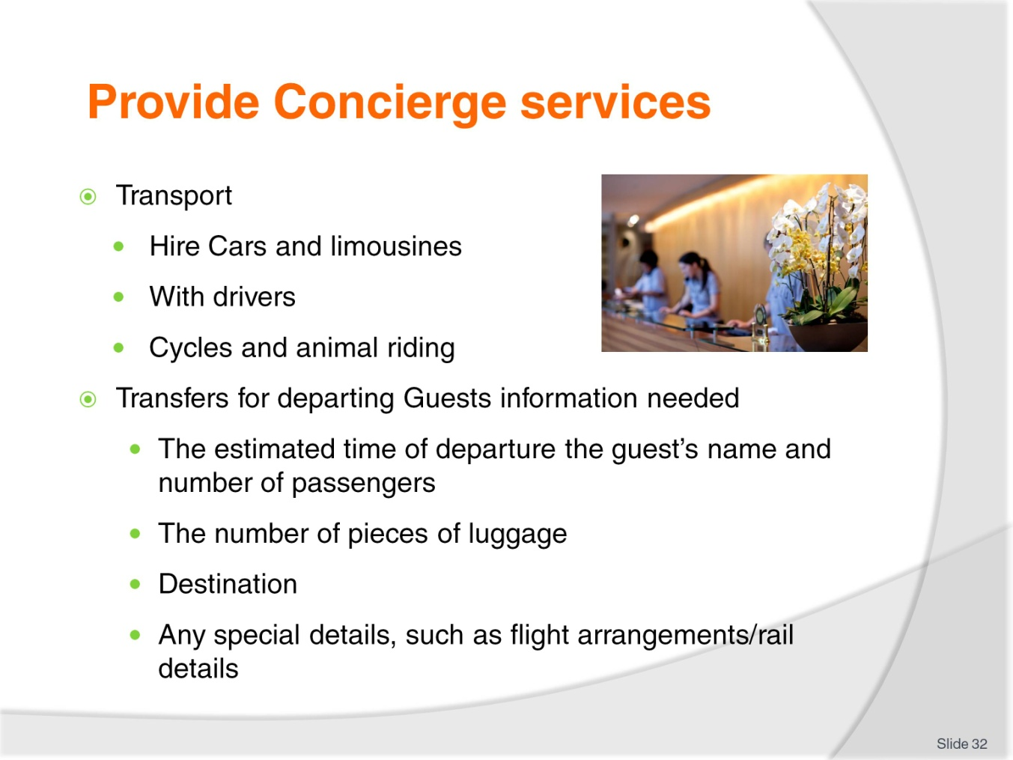
Slide No | Trainer Notes
Transport include:
Hire cars
Limousines
Other local style transport such as cycles, taxis, carriages
Riding on an animal – horses, donkeys, goats, elephants dolphins etc
Bus transport
Water transport such as water taxi, ferry, private hire.
Transfers for departing Guests
Whatever form of transport is arranged, certain information is needed:
The estimated time of departure of the guest
The guest’s name and number of passengers. If children are included then booster seats, capsules or other requirements need to be considered
The number of pieces of luggage
Destination
Any special details, such as flight arrangements/rail details.

Other information that may that may need to be taken into consideration include:
Whether disabled/wheelchair access is required
Whether there is a large amount of luggage
If there are large, cumbersome items to transport.

Slide
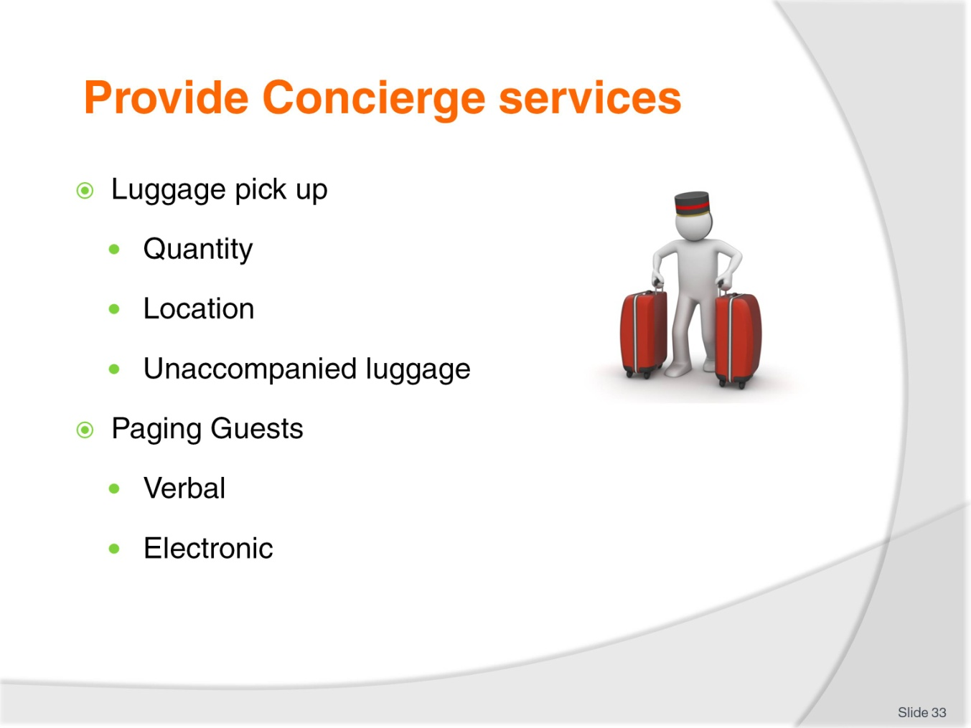
Slide No | Trainer Notes
Luggage pick up
How much luggage there is and the type of luggage , there may be a need for more than one porter and trolley
Where is the luggage? Guests room the guest may have luggage in storage or items to be collected from local vendors or customs agents if they have purchased an item that needs certification
What time is the guest due to leave the hotel or resort as they may require luggage to be stored for a short time
Whether the luggage is to be loaded into a car or commercial transport.
Paging guests
Messages are still carried to guests in this way in some hotels especially those with historical or period themes
Currently messages are more likely to be forwarded by text to a mobile phone or accessed on an iPhone or notebook
Staff are also paged in this way to meet guest requests. With modern VOIP [Voice over Internet Protocol] computer generated messages can be sent instantly, porters may use.

Slide
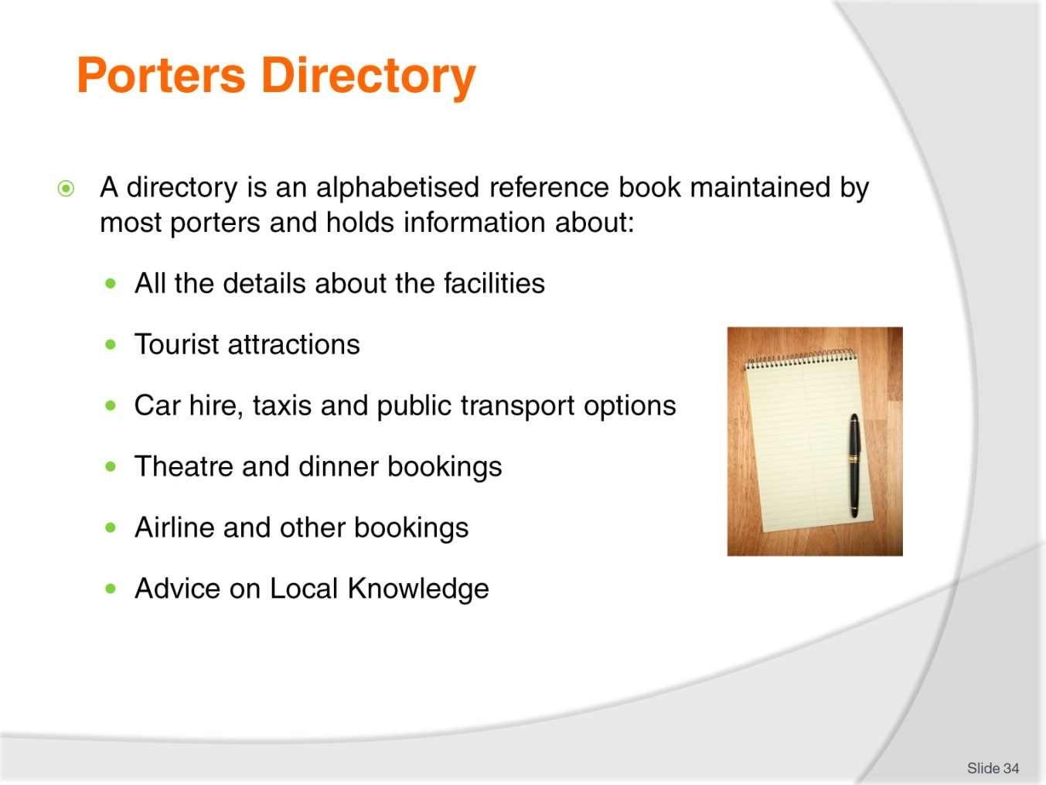
Slide No | Trainer Notes
Most porter’s desks maintain a directory. Usually maintained alphabetically, the directory gives the porter the information needed quickly and efficiently. It isn’t always convenient to ask a colleague the answer to a question or rely on memory. The directory contains information relating to places, costs, directions and service providers and a list of contacts and telephone numbers for those harder to get items
Local Knowledge
Seasonal influences (e.g. pilgrimage season, best times to see particular flora or fauna)
Children’s parks tourist developments
Natural heritage sites
Local markets
Museums.
Keep up-to-date with industry information so that you:
Can give guests and junior team members information
Know what is going on in your property and industry
Promote products and services and help meet guest expectations.

Slide
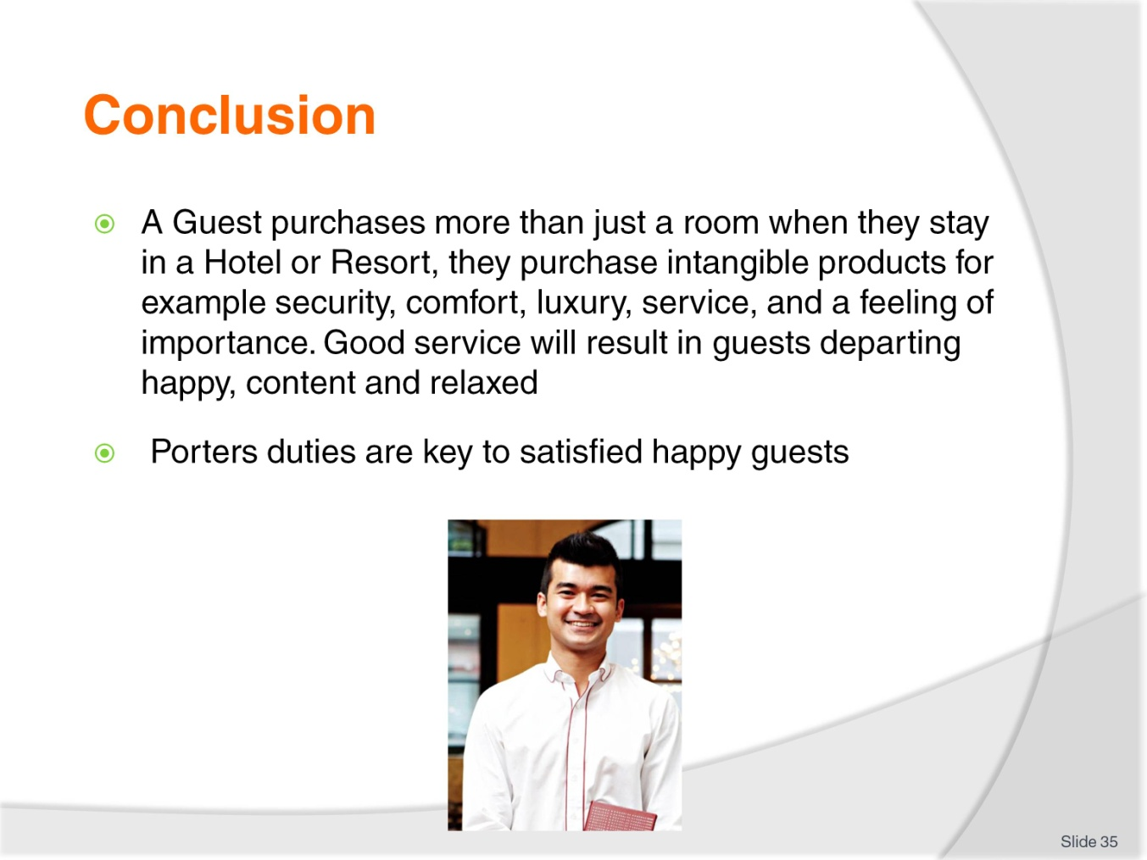
Slide No | Trainer Notes
A Guest purchases more than just a room when they stay in a Hotel or Resort; they purchase intangible products for example security, comfort, luxury, service, and a feeling of importance.
Good service will result in guests departing happy, content and relaxed. Porter’s duties are key to satisfied happy guests.

Slide
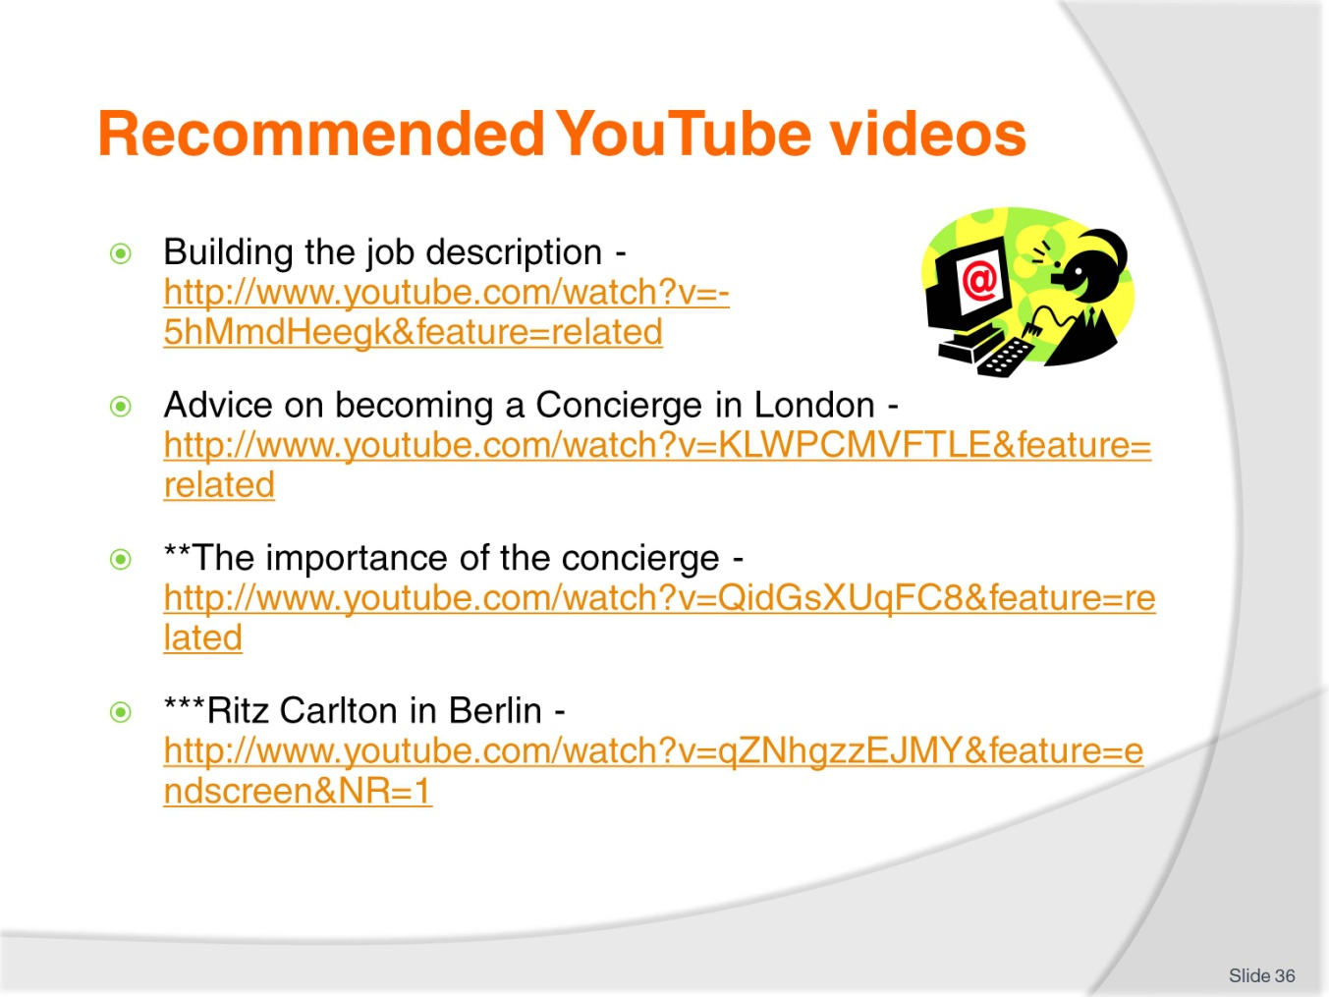
Slide No | Trainer Notes
Trainer to recommend YouTube videos for trainees to view.
Trainer thanks trainees for their attention and concludes the unit.

Recommended training equipment
Porter trolley
Sample Luggage
Luggage tags
Computers
Property management system (e.g. Opera)
Printer
Tourist Information, brochures etc
Templates for bookings for external businesses (e.g. tour companies)
Pens
Notepads

Instructions for Trainers for using
PowerPoint – Presenter View
Connect your laptop or computer to your projector equipment as per manufacturers’ instructions.
In PowerPoint, on the Slide Show menu, click Set up Show.
Under Multiple monitors, select the Show Presenter View check box.
In the Display slide show on list, click the monitor you want the slide show presentation to appear on.
Source: http://office.microsoft.com
Note:
In Presenter View:
You see your notes and have full control of the presentation
Your trainees only see the slide projected on to the screen
More Information
You can obtain more information on how to use PowerPoint from the Microsoft Online Help Centre, available at: http://office.microsoft.com/training/training.aspx?AssetID=RC011298761033
Note Regarding Currency of URLs
Please note that where references have been made to URLs in these training resources trainers will need to verify that the resource or document referred to is still current on the internet. Trainers should endeavour, where possible, to source similar alternative examples of material where it is found that either the website or the document in question is no longer available online.

Appendix – ASEAN acronyms
AADCP | ASEAN – Australia Development Cooperation Program.
ACCSTP | ASEAN Common Competency Standards for Tourism Professionals.
AEC | ASEAN Economic Community.
AMS | ASEAN Member States.
ASEAN | Association of Southeast Asian Nations.
ASEC | ASEAN Secretariat.
ATM | ASEAN Tourism Ministers.
ATPMC | ASEAN Tourism Professionals Monitoring Committee.
ATPRS | ASEAN Tourism Professional Registration System.
ATFTMD | ASEAN Task Force on Tourism Manpower Development.
CATC | Common ASEAN Tourism Curriculum.
MRA | Mutual Recognition Arrangement.
MTCO | Mekong Tourism Coordinating office.
NTO | National Tourism Organisation.
NTPB | National Tourism Professional Board.
RQFSRS | Regional Qualifications Framework and Skills Recognition System.
TPCB | Tourism Professional Certification Board.







